University of Plymouth

School of Engineering,

Computing, and Mathematics

COMP3000

Computing Project

2022/2023

Helping   
A cosy serious game that teaches healthy wellbeing habits

Josie Wood

10509521

BSc (Hons) Computing & Game Development

## 

## 

## 

## Acknowledgements

I’d like to thank all the staff, friends, and family who have supported me throughout the last few years of my degree and made this all possible.

In particular, thank you to all of the Game Dev staff, past and present, who provided a great environment for me to learn all these amazing new skills and supported me throughout various bouts of illness and absence. Thank you, Swen, for supervising this project remotely and helping me stay on track and motivated.

Thanks to Alex Pritchard for your continued support throughout the course and encouraging me that cosy and wholesome games are valuable and worth making.

Thanks to the Wood family for supporting my decision to do this degree and doing everything possible to support me and make me feel loved, even from afar.

And finally, thank you to Jack Brewer, my biggest supporter from day one, without whom this wouldn’t have been possible.

## Abstract

Managing and looking after mental health is as important as maintaining good physical health, but people aren’t always taught the best practices and techniques to do so. In some cases, this can lead to people only receiving support once they reach a ‘breaking point’, rather than learning preventative and healthy habits early on.

In recent years, more people than ever are playing video games and feeling the mental health benefits - community, relaxation, and rest time. As the industry has grown, so has the number of games centred around mental health, and the wholesome games movement.

This project aims to combine these two elements to create a game which improves players mental wellbeing.

Informed by thorough research and investigation, a vertical slice of gameplay applies the serious game framework and behaviourism theories of learning to teach users about one of the more accessible and less commonly learnt approaches to managing mental wellness, nature-based therapy.

The result is a product which offers short term benefits of relaxation and escapism while being played, as well as long term affects as players learn about new ways to improve their wellbeing and can begin applying these new habits outside of gameplay.

## Table of Contents

Acknowledgements 1

Abstract 2

Table of Contents 3

1 - Introduction 6

2 - Background, objectives & deliverables 7

2.1 Project Background 7

2.2 Preliminary research 7

2.3 Objectives 10

2.4 Deliverables 10

2.5 Competitor analysis 10

3 - Literature review 12

3.1 Psychological approaches to managing mental illness. 12

3.2 Learning and Serious games 13

4 - Method of approach 15

4.1 Tools 15

4.2 Project Management 16

4.3 Data collection procedures 17

5 – Implementation 17

5.1 Mental health and wellness content 18

5.2 Serious games principles, educational approach 19

5.3 Narrative and Game design 20

5.4 Technical implementation 23

5.5 Art and visual design 27

5.6 Localisation 30

5.7 Accessibility 30

6 - Legal, social, ethical, and professional issues 31

6.1 Data Collection 31

6.2 Mental health content 31

6.3 Foraging content 31

7 – Project Reflections 32

8 – Future development 33

9 - End-of-project report 33

References 35

Appendix 1 – Game Design Document 36

Appendix 2 – Data Collection and User Testing 53

Word Count: 9947

Code link: https://github.com/josie-wood/COMP3000

## 1 - Introduction

Managing and looking after mental health is as important as maintaining good physical health, but people aren’t always taught the best practices and techniques to do so. In some cases, this can lead to people only receiving support once they reach a ‘breaking point’, rather than learning preventative and healthy habits early on. This breaking point is demonstrated with the demand on emergency health care services, such as the London Ambulance service; as of 2019, 10% of the calls to the service were mental health related. (NHS , 2019)

In recent years, more people than ever are playing video games and feeling the mental health benefits - community, relaxation, and rest time. A survey conducted during lockdown found that 50% of people who play games in the UK agreed with the statement ‘*Playing video games helped me feel happier’* (ISFE, 2020). As the industry has grown, so has the number of games centred around mental health, and the wholesome games movement.

This project aims to combine these two elements to create a game which improves players mental wellbeing.

In preparation for this, extensive research has been undertaken into both mental health care and educational media. In terms of mental health care, the aim of research was to identify the industry standard practises followed by psychologists and mental health professionals to understand and manage mental wellness techniques, so that these techniques and habits may be delivered as taught content in the game. Analysis of educational media provides insight into both how people learn, looking at established psychological theories such as behaviourism, as well as frameworks by which media such as games can be designed to support and encourage learning, such as the Serious Games Framework (Yusoff, et al., 2009).

Using the research as reference, a vertical slice of gameplay has been created to demonstrate how a game can apply techniques of learning theories and serious game design to improve users’ mental health habits. This proof of concept utilises behaviourism and the serious game framework to teach users about nature-based approaches to improving mental wellbeing, wrapped up in a cosy narrative game with pleasing visuals and engaging gameplay. Hand-drawn art assets with a cohesive theming and use of colour contribute to the aesthetic appeal of the product. Established concepts of game and narrative design are implemented to create entertaining storylines and gameplay that draw users in.

The result is a product which offers short term benefits of relaxation and escapism while being played, as well as long term effects as players learn about new ways to improve their wellbeing and can begin applying these new habits outside of gameplay.

## 2 - Background, objectives & deliverables

### 2.1 Project Background

Games for wellbeing and mental health fall into the subcategory of serious games (or applied games). There’s no single definition of a serious game, but the most used is ‘Games which do not have enjoyment, entertainment, or fun as their primary purpose’ (Chen & Michael, 2005).

Serious games have existed since the early days of video games, and multiple titles have reached high levels of popularity and financial success. One of the earliest examples is the Microsoft Flight Simulator franchise, the first edition of which was released in 1982. It is one of the few flight games which focuses on civil aircraft and doesn’t feature combat. The 40th anniversary addition released in 2022 reported over 10 million players and is still receiving updates (Neumann, 2022). In addition to commercial success, studies have suggested that the game has ‘capability to improve novice student performance in an aircraft’ (Callender, et al., 2009), supporting the educational benefits of serious games.

The design of serious games specifically to improve mental health has also proven successful. A meta-analysis of ten studies into serious games for mental health suggested that they can be effective for reducing disorder-related symptoms in patients (Lau, et al., 2017).

### 2.2 Preliminary research

#### Research aims

To further establish the background of this project, a survey was created to explore the topics of Media and Mental Health.

This research aims to help develop the background of the project and identify key concepts to be further investigated throughout the project. The questions aren’t directly related to the proposed product, but rather, to people’s attitudes and experiences with the subjects. There is a mix of qualitative and quantitative data points, to allow for trend analysis and identification of specific areas that respondents resonate with.

#### Demographic of respondents

The survey received 17 responses.

Most of these respondents identified themselves as being aged 18-24 (76%) and employed (88%), but there were also 4 respondents aged between 25 and 64, and 2 respondents that identified as a student or unemployed. There was no clear gender divide amongst respondents, with a mixture of cisgender, transgender, and gender non-conforming identities.

This is a useful demographic for this research – the proposed product is most likely to be popular amongst 18–24 year-olds, and the insights from a variety of backgrounds bring new perspectives to inform development.

#### Media consumption

The media section of the survey aims to gather insight into how subjects interact with media on a regular basis, and how it has affected their life.

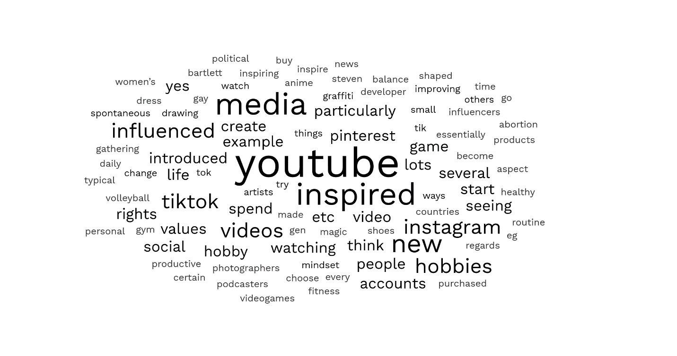One of the questions asks if respondents have ever been inspired to change something in their life by media. This aimed to see how often media can affect audiences and gain some insight what types of media inspire people to make what sort of changes.

Figure : Word cloud of responses from Question 3 of the Media section of the Media and Mental Health Survey. See User Testing and Data Collection in Appendix 2 for more details.

Looking at the world cloud generated from the responses, commonly identified media formats and products that inspired change include YouTube, videos, Instagram, and Pinterest. These are all visual forms of media, suggesting that people are more likely to be inspired to make change after seeing something depicted visually in their media. In application to the proposed product, this supports the delivery of the story and narrative alongside visuals and characters who ‘act out’ the actions and behaviours discussed.

Another question asks, ‘Can you think of a time you've inadvertently learnt something from a piece of fictional media?’, aiming to understand how many people have experienced an educational benefit from consuming entertainment focussed media.

12 of the respondents identified specific topics and facts they learnt from media, ranging from learning about history and philosophy to learning about society and diversity. This supports the concept of entertainment media as an educational tool, with many people from across demographics all having learnt from media throughout their lives.

#### Mental Health experiences

When asked if they would describe themselves as having any mental health conditions, 11 of the 17 respondents answered and shared their conditions. This high level of mental illness will produce a slightly skewed representation of how people in general experience wellness, but will in turn provide a more thorough insight into the self-care habits and techniques practised by people already struggling.

One question asked *Regardless of whether or not you have any mental health conditions, do you feel like your mental health and emotional wellbeing could be improved?* All 17 people answered this question, and an overwhelming 88.2% of them answered that yes, their mental health and wellness could be improved. Only 2 respondents answered otherwise.

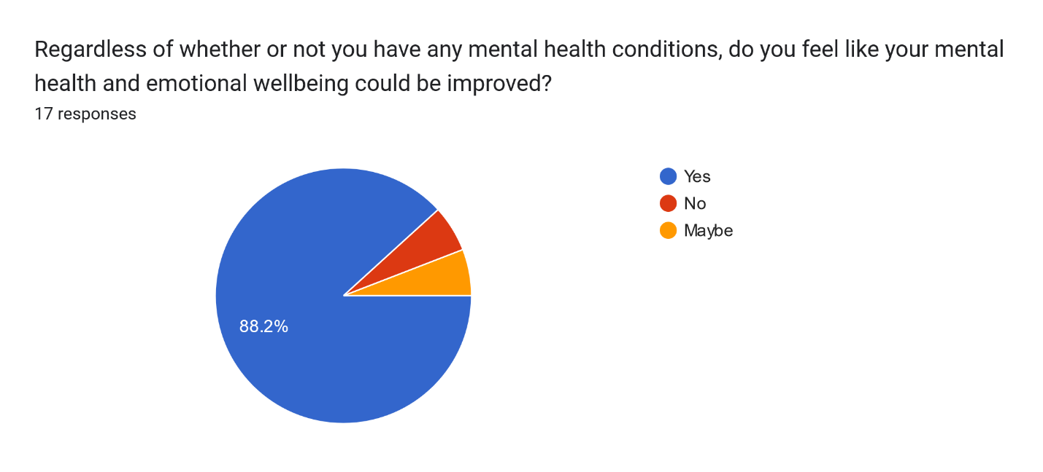This result supports the creation of the proposed product, to teach players about healthy habits and techniques to improve their mental health via a game which is enjoyable and relaxing to play.

Figure : Pie chart showing responses to Question 2 of the Mental Health section of the Media and Mental Health survey. See User Testing and Data Collection in Appendix 2 for more details.

To gather insight on how people currently look after their mental health, one question asked what people would do if they were feeling stressed or upset. The long form written answers provide qualitative data which is particularly useful to gather deeper insight into people’s actions and motivations. Of the 16 responses, common themes include taking part in hobbies, talking problems through with friends or family, and meditation techniques. These are all good examples of dealing with such feelings and align with advice given by medical professionals.

Some responses, however, suggest individuals who don’t currently have the tools to manage these feelings – one response simply wrote ‘sleep’, while others mentioned shutting down and isolating themselves. These are common responses to low mood and suggest that some of the respondents would benefit from learning more about maintaining mental health and finding solutions that work for them.

These descriptions are used to inform the description and behaviours of characters in the game struggling with mental health to make them feel more believable and relatable.

### 2.3 Objectives

The primary objective of this project is to create a serious game that provides entertainment and escapism whilst simultaneously teaching the players good mental wellbeing practices.

To better understand this objective and stay on task throughout development, it has been broken down into smaller, measurable objectives as follows.

* Write at least one character dialogue with a full storyline that they player can interact with. Once completed, send out as a standalone text game to at least 5 testers for early feedback.
* Write at least 5 minutes’ worth of dialogue for the player to read by the completion of the project. Measure this by entering the wordcount into wordstotime.com.
* Make a slice of gameplay that can run from start to end without any major errors or bugs (for example, software doesn’t crash, players can move around and access the storyline as expected).

### 2.4 Deliverables

The deliverables for this project include both the working build of the game and the research that informs it.

The working game is delivered as an executable which can be played on a PC with keyboard. The game is a vertical slice of the full product, with limited characters and storyline to interact with, with the intention that it can be built upon and expanded at a later point. All art assets featured will be original, and copies of the original PSD files is available in the submission folder.

The game design document is delivered as a PDF which contains all of the information needed to reproduce the game from scratch, as well as detail which could be used to expand the product with future development.

### 2.5 Competitor analysis

Although there are no products exactly like the proposed product currently available, there are both digital tools for mental health education and games which broach the topic of mental health. Some of these examples have been analysed to identify similarities and differences to the proposed product to make it a uniquely useful resource for users.

For a more in-depth competitor analysis of products outside of the examples provided here, see the Game Design Document in Appendix 1.

#### Headspace

Headspace is a website and mobile app for iOS and Android which provides guided meditation resources for users. It teaches mindfulness techniques, and it aimed at anyone who wants to introduce relaxation to their life. Research into Headspace has proven it’s effectiveness - studies have found a significant increase in wellbeing, reductions in anxiety and depressive symptoms, significant reductions in diastolic blood pressures, significant increases in perceived job control, as well as a significant reduction in sleeping problems.

Similarly to Headspace, the proposed product is informed by science and psychology and aims to be easily playable in short bursts so users can dip in and out as they please.

However, rather than being delivered as a purely meditation-based resource, the proposed product is in the form of a cosy game, providing entertainment as well as support. This makes it appeal to a different audience who don’t want to commit time just practicing meditation, but who also want to get some escapism and gameplay while they learn. The proposed game also aims to teach users about good habits they can practise outside of interacting with the game, in contrast to Headspace which is designed for users to keep returning to when they want to practise meditation.

#### Night in the Woods

Night in the Woods is a narrative game which focuses on exploration, story, and characters. The themes addressed include mental illness, depression, the stagnancy of the middle and lower classes, and the slow death of small-town America. While the main purpose of the game is entertainment, it also depicts mental health realistically and is praised for its representation.

The proposed product is a similar style of character driven game, showing characters with mental health issues, with branching dialogue options to tailor the experience based on user actions and choices.

In contrast to Night in the Woods, the proposed game aims to not only represent mental health issues, but actively teach users about how to better manage symptoms and encourage healthy wellness habits. This shapes how the story is told because it will be designed around principles of learning and will have an overall message of hopefulness. Ideally, the proposed product will have gameplay and story which is as engaging as Night in the Woods, so will attract the same entertainment focused audience, whilst also appealing to users who want to learn more about and practise mental wellbeing skills.

## 3 - Literature review

### 3.1 Psychological approaches to managing mental illness.

#### NHS treatment and trends

The NHS classifies a group of the most prevalent anxiety and depression disorders as Common Mental Disorders, or CMDs (National Health Service, 2016). They characterise CMDs as disorders which *“cause marked emotional distress and interfere with daily function, but do not usually affect insight or cognition”*, and note that despite their comparative lack of severity, their prevalence among the population makes them a large burden to society as a whole.

As of the 2014 APMS interview, medication was the most common treatment prescribed to respondents for mental health, accounting for 11.6% of results compared to just 3.0% of people receiving psychological therapy. Of the psychological therapies offered by the NHS, Cognitive Behavioural Therapy (CBT) is the most used, followed by counselling and other therapies. (National Health Service, 2016)

Studies have suggested that the most effective approach for treating depression and anxiety disorders is a combination of medication and CBT, in part because the combined approach is more acceptable to many patients who struggle with mental health stigma. (de Jonghe, et al., 2001).

Whilst the Improving Access to Psychological Therapies programme introduced in 2008 aims to reduce waiting times for psychological therapy to 6 weeks from referral, in practice in 2013 one in ten people were waiting over a year to receive treatment. (We need to talk coalition, 2013).

#### Cognitive Behavioural Therapy

Cognitive Behavioural Therapy is an approach to treating psychiatric disorders that is built around Beck’s model of the Cognitive Triad. (Beck, 1979). In summary, this theory identifies a cycle of behaviour, thoughts, and feelings which influence one another. Individuals struggling with mental health issues need to identify and break this cycle to feel better, for example by looking critically at their negative thoughts and finding evidence to disprove them. (Gatchel & Rollings, 2012)

#### Counselling

Counselling is a type of talking therapy that can help patients cope not only with mental health issues, but with complicated emotions that may emerge because of life events, physical health conditions, or identity issues. (NHS UK, 2020) A trained therapist encourages the patient to talk openly about their feelings, and can suggest techniques to help the patient understand and solve their issues based on the situation. These techniques can arise from several different psychological approaches, including Humanistic, Cognitive, Behavioural, Psychoanalytic, Constructionist or Systemic. (McAdams, 2023)

#### Alternative approaches: Nature-based therapies

Nature based therapy, or eco-therapy, is a new way of looking at mental health and how it is connected to the world around us. First conceptualised in 1992, Theodore Rozak stated that the core principle of ecopsychology is that *‘there is a synergistic interplay between planetary and  
personal well-being’*. (Roszak, 1992). Although this is an extreme statement, the attitude is mirrored by the more widely known and accepted systemic approach to mental health; the individual patient is affected by their relationships and interactions within a larger group.

Nature based therapies are generally centred around doing outdoor activities in nature. (Mind UK, 2021) The activities themselves can vary from animal-assisted therapy and environmental conservationism to wilderness therapy and exercising outside.

Mind UK suggests the following activities to help patients explore using nature to improve their wellbeing:

* Grow or pick food.
* Bring nature indoors.
* Do activities outdoors.
* Help the environment.
* Take notice of nature.
* Connect with animals.

Each of these align with Rozak’s initial description of ecopsychology and provide an accessible way for patients to take small steps to improve their mental wellbeing.

Studies have shown that nature-based therapies have a positive impact on patients suffering from diverse diagnoses, spanning from obesity to schizophrenia. (Annerstedt & Währborg, 2011). More generally speaking, research has shown that people who spend 120 minutes a week in nature are more likely to have good health and mental wellbeing. (White, 2019).

On the other hand, nature-based therapies aren’t always as accessible to patients as other treatment methods. Patients living in cities, who don’t have their own transportation, or who work full-time are less likely to be able to get out into nature, especially on the regular basis required to make a sustained change to mental wellbeing. Additionally, patients struggling with serious mental health concerns may be reluctant to try a treatment which could be misconstrued as minimising their problems.

### 3.2 Learning and Serious games

#### Psychological theories on learning

Whilst a full analysis of psychological learning theories is out of the scope of this paper, a brief explanation of the key approaches is given to provide context on how serious games can educate their players.

Piaget is one of the earliest theorists of constructivism, a learning theory which suggests that rather than passively absorbing information, people learn by experiencing the world and using those experiences to build their own knowledge base. (Brau, 2020). Instructors facilitate learning, presenting ideas and concepts to learners who must then reflect on previous knowledge and use new information to come to their own conclusions and build up their knowledge base. (Piaget, 1952)

Constructivism is, however, criticised for failing to acknowledge the importance of tangible items in the process of learning about them, encouraging social thinking, and leading to poorly structured education that leaves struggling students behind.

Bandura’s social learning theory puts more emphasis on learning from others, rather than alone. It is a behavioural approach that emphasizes the importance of observing, modelling, and imitating others. Another person must model a behaviour, and if the observer pays attention, retains the memory of the behaviour, is able to reproduce it and is motivated to do so, then they will imitate the behaviour themselves, thus learning it. (Bandura, 1977)

The biggest critique of social learning theory is that it doesn’t account for the internal thought processes of the individual which contribute to whether they decide to imitate the behaviour. It is deterministic and ignores the effect of free will.

#### Serious Games Conceptual Framework

The Serious Games Conceptual Framework is a model proposed by researchers at the University of Southampton to identify a clear structure of both learning and gaming requirements which should be met to create a successful serious game. (Yusoff, et al., 2009).

In this structure, learning outcomes are defined using the instructional content, or subject matter being taught, in combination with the capability of the player. An example of this kind of learning outcome could be ‘user can recall all of the cities they were taught about’. The learning activity should aim to achieve the learning outcome using the game attributes, such as interaction or in-game rewards. The genre and achievement objectives of the game should align with the learning activity and outcomes the developer wants to instil in users.

This framework provides a good structure for developers to create serious games, which didn’t exist prior to its creation. However, as a relatively new concept, there is a lack of scientific study and research to support its effectiveness in producing successful serious games.

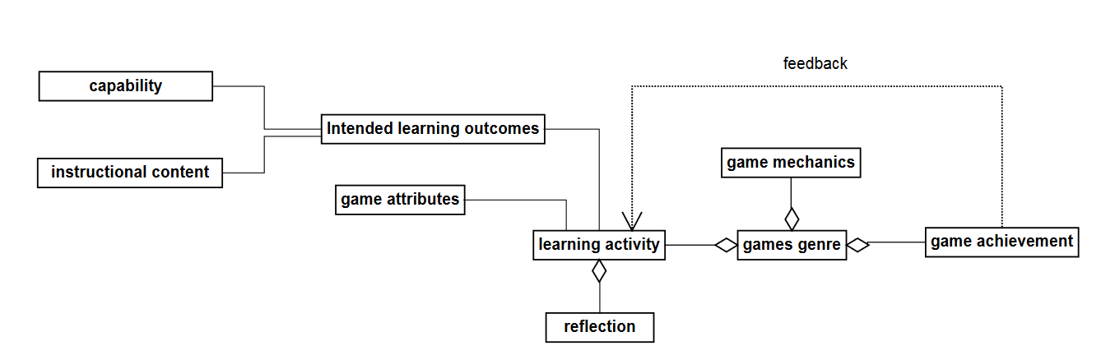

Figure : Flowchart demonstrating the Serious Games Conceptual Framework

## 4 - Method of approach

### 4.1 Tools

#### Asset Creation

All the visual elements of this project have been custom made using the Game Design Document as reference.

The 2D sprites, including characters, environments, and user interface, are made in Adobe Photoshop. They can all be found as both PNGs and original PSDs in the assets folder.

#### Development

The game is developed in the Unity engine. The development environment is Visual Studio for Unity is used, and all executable code is written in C#.

The branching narrative is written using YarnSpinner, an opensource dialogue tool that has Unity integration.

#### Project Management

Google sheets is used for planning and tracking development, for example, the creation of the Gantt chart.

Trello is the primary sprint planning tool. A Kanban board is regularly updated to keep track of tasks.

Git and the GitHub Desktop application are used for version control.

### 4.2 Project Management

#### Start of the project

At the start of the project, the Gantt chart was created in Google Sheets, informed by the project vision and risk analysis outlined in the Project Initiation Document.

To account for the biggest risk to the project, delays due to chronic illness, three buffer periods were planned into the Gantt chart to make up for any missed time. In winter of 2022 a prolonged period of illness halted development. Because of the planned buffer periods, a few months of illness only put the project 3 weeks behind schedule. A revised Gantt chart was created in January to account for this delay and add more buffer periods in the following term.

The Trello board was also started at the start of the project. It is a Kanban board with columns for *Backlog*, *To-do this sprint*, *Doing*, *In Review*, *Completed this sprint*, and *Finished* tasks. Cards were created and placed in the Backlog column using the Gantt chart tasks, and were colour coded and labelled according to sprint.

An empty Sprint Record document was started with sections to document the sprints as the project progressed.

#### Sprint Process throughout the project

Each sprint completed during the project consisted of the following key steps.

**Sprint planning** – In Trello, move items from *Backlog* to *To-do this sprint*. Write up the plan in the Sprint Record.

**During sprint** - Work on current items and move them in Trello to *Review* and then *Completed this sprint*.

**Sprint Review** – Take a step back to review work completed. Move Trello cards from *Completed this sprint* to *Finished.* Write up completed work in the Sprint Record, answering the questions:

* What did I do this sprint?
* What went well?
* What didn’t go well?
* Were there any blockers?
* What actions can I take to avoid/work past these blockers in future?

**Backlog refinement** - Look at the state of the project, remaining time, and project goals and use this to add, remove, or edit items in the Trello backlog ready for the next sprint. Ensure all branches of version control are up to date with one another before starting a new sprint.

Every two weeks, a meeting was held with the supervisor to discuss progress and receive advice on the project.

### 4.3 Data collection procedures

Data collection and user testing has been used throughout the project to help inform development.

Every user testing and data collection session follows the same basic procedure for setup, execution, and analysis.

#### Set up

Each testing session should have a clear objective/question to answer and be relevant to the project. This objective should be documented before the session goes live and referred to in the analysis stage.

#### Execution

At the data collection stage, a disclaimer outlines how the results will be used, and how participants can withdraw from the study if desired, to ensure ethical standards are met.

The testing sessions must be public until at least 5 responses have been gathered.

Any questions asked of participants need to be carefully considered to ensure:

* A mix of qualitative and quantitate data is gathered.
* Questions are rephrased in both directions to avoid leading bias.
* All respondents answer questions in the same order with the same context.

#### Analysis

All data collection and testing sessions are documented in *Data Collection and User Testing*. Each entry in this document includes details of:

* The start dates.
* Aim of the research.
* Format of research. (survey, questionnaire, any additional materials provided to users)
* List of any artefacts created.
* Number of respondents.
* Point-by-point analysis of each result: explaining what the question aimed to identify, summarising the results, and outlining how the findings can be applied to the product.

## 5 – Implementation

The project vision was carried out to deliver a game which surpasses the Minimum Viable Product.

The result is a story driven game with branching narrative options, following a player character who is new to town and looking to make friends. The player interacts with Mouse, learns about their life, mental health, and old hobbies. Using this information, areas are unlocked for the player to explore and forage in to encourage the Mouse to join them and take a walk out in nature, one of the nature-inspired techniques to improve mental wellbeing. This teaches players about these techniques whilst also providing entertainment in a relaxing environment with cosy visuals.

Each aspect of the implementation is documented in detail in the following sections.

### 5.1 Mental health and wellness content

To establish a background for the mental health aspect of the game, the *Media and Mental Health* survey asked respondents about their experiences and attitude regarding mental health issues.

Some of the questions looked at how people currently deal with strong emotions. Common themes of nature, exercise, and mindfulness ran throughout the responses, which helped inform the approach to treatment the product would focus on.

For more information on the *Media and Mental Health* survey, see *Data Collection and User Testing*.

The game focuses on nature-based therapies and mindfulness as techniques to help manage mental health. These techniques were chosen for the following reasons:

* Responses in *Media and Mental Health* suggest a willingness and success in respondents to utilise these approaches in their daily lives.
* They are both easily applied to a self-help context: mindfulness techniques are focused on the self by design, and whilst formal nature-therapy requires a trained therapist, the principles and exercises can be practiced independently with minimal supplies.
* Using nature to improve mental health is less well known than formal therapies such as CBT and counselling, so it’s helpful to be able to bring awareness of it to an audience who otherwise may not have considered it.

Because the product delivered is a vertical slice of gameplay, only one character could be introduced for the player to interact with and help.

The chosen character, Mouse, is represented as an individual that struggles with feelings of anxiety, and depression. These are some of the most experienced symptoms of poor mental health, so choosing to represent them in the non-player-character encourages the audience to empathise with and understand them.

The storyline to help Mouse involves the ‘do activities outside’ element of using nature to improve wellness, as identified by Mind UK (Mind UK, 2021). The player explores and plans a woodland trail for them to follow and experience immersion in nature. In exploring individually first, the player gets the fun and enjoyment of the exploration mechanic and navigating through the woodland. This offers the short-term enjoyment and relaxation element of gameplay.

When this route is introduced to the Mouse and they are also helped, it supports the idea that an outside activity such as following a trail can help improve wellness and mental health, offering the longer-term knowledge and understanding.

### 5.2 Serious games principles, educational approach

The learning elements of the game are designed following the Serious Game Conceptual Framework (SGCF) (Yusoff, et al., 2009) and the concepts of modelling identified in the behavioural approach to learning. There are two levels of learning involved in the game – the player character and non-player-character (NPC) learn from one another to manage their mental health, and the user learns from their interactions and the gameplay to improve their own mental health.

In the application of the Serious Games Conceptual Framework, every element of the game play and design relates to a stage in the framework.

To ensure capability, meaning the players are capable of learning and applying the content, the instructional content is focussed is on mindfulness and nature-based therapies, two accessible applications of psychology to improve mental health with minimal resources or complex psychological understanding required. For more information on the psychological side of the project, see *Mental Health and Wellness Content*.

The intended learning outcomes are identified using the capability and instructional content, in this case, ‘player can understand and apply mindfulness and nature-based therapy principles to improve mental wellbeing’.

This is translated into the game as the learning activity. The genre is narrative story game, and as such the main mechanics are interacting with NPCs and the game world. Achievements in the game are based on successfully deducing information from interactions with the NPC, exploring the world to find items, and eventually taking the NPC on a woodland walk. Each of these tasks and achievements teaches the user about how mental health can affect people, and how being out in nature can help soothe some of those issues.

In addition to following the SGCF, the behaviourist model of learning through modelling is applied to reinforce learning outcomes.

In the story, the player models the healthy behaviours for the Mouse, reminding them and teaching them that they are also capable of completing the steps and feeling the positive benefits. After observing the player character start the conversation with them, forage for wild food, and embark on an adventure in the woods, the Mouse feels confident to imitate the behaviour and join the player on a new adventure.

In turn, both characters in the game model the healthy habits for the user themself. The player observes characters with poor mental wellbeing establish a new friendship, venture out to try a new hobby outside, and go on a walk through the woods to ground themselves.

They also get the see the positive impact it has on the characters as they discuss feeling better due to their actions, thus providing motivation for the user to imitate their actions to improve their own mental wellbeing.

### 5.3 Narrative and Game design

#### Narrative Design

As a story driven game, the narrative design is one of the most important elements of making the project feel complete and enjoyable.

A key consideration in the narrative design is ensuring that the story is built around the gameplay, rather than slotting gameplay elements in between narrative points. In this instance, this means looking at how the character can interact with the world and building the narrative around that.

The primary objective of the game is to help another character using mindfulness and nature-based therapy techniques to improve their mental health, in turn teaching the user about these techniques. This means that the player character must interact with someone who could benefit from this help, have a reason why they haven’t helped before, and be in a setting where this type of help makes sense.

In order to satisfy these gameplay requirements, the narrative of the game follows a player character who is new to a small, nature surrounded village, and who meets a new neighbour who exhibits signs of low mood and anxiety.

#### Writing and dialogue

Dialogue between the player and the Mouse is the main element of gameplay, so this writing is important in making the game fun, interesting, and educational.

The writing style and voice was defined before any dialogue was written, to ensure that it suits the narrative and to provide a framework to refer to throughout the writing process.

Because the project is so dialogue heavy, sentences are kept short and snappy, so they don’t become a wall of text for the player to read through. In addition, the tone of both characters is chatty and informal, aiming to mimic natural speech as much as possible so it doesn’t feel like reading a novel. This also supports their characterisation as people who are friendly and relatable despite their struggles.

To test the dialogue writing style, a short dialogue demo was created and sent out to testers before actual dialogue was written. This aimed to gather user feedback regarding the writing style, and how well characters are communicated using text-only. The general response was positive, with testers enjoying the chatty nature and thorough descriptions of characters. There was some feedback about how the tone of answers seemed to change throughout the dialogue, making the story feel disjointed.

As a result, in the final dialogue, more care was taken to create branching options that deliver the same content but with different tones and attitudes based on previous interactions. For a detailed breakdown on the Dialogue Demo and its results, see the *Data Collection and User Testing* document in Appendix 2.

In addition to the changes made as a result of testing, the writing style was also adjusted to account for the restrictions of implementation in the game. In the demo, longer form sentences from the point of view of a narrator describe the character and interactions to the player. In the actual game, forever, there was no easy way to implement this narrator in a way that felt natural and in keeping with the rest of the game. Therefore, the content delivered by the narrator was replaced by an internal monologue which displays the characters thoughts in thought bubbles throughout dialogue scenes. This is written in a shorter, snappier form to mimic the player character voice, making it useful not only to describe the world the player sees, but also to add personality and context to their choices and actions.

To plan the branching dialogue options and the interactions needed to fulfil the narrative, a dialogue flow diagram shows the dialogue with the Mouse character in terms of key interactions and results.

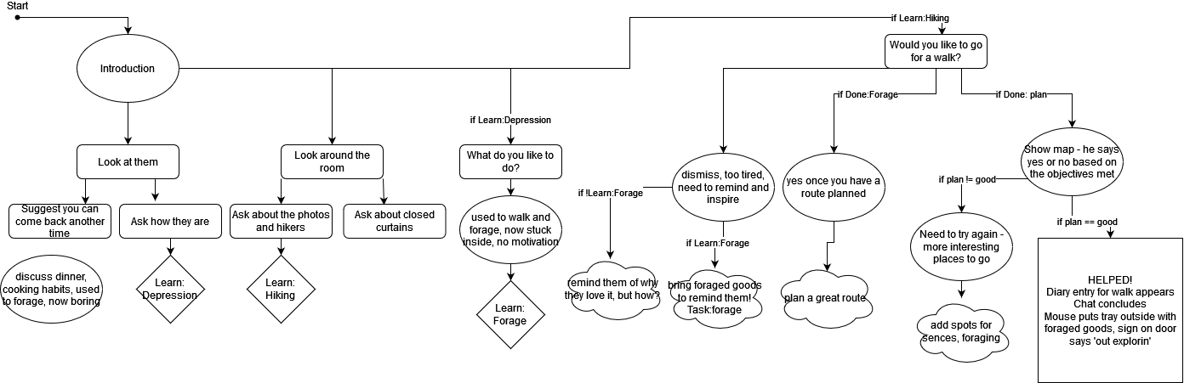

Figure : Flow chart demonstrating the branching dialogue options for the Mouse character

#### Level Design

A key element of the game is the woodland area which the player explores to find good foraging spots to show to Mouse. In the vertical slice provided in this project, this is the only mechanic the player experiences apart from the primary dialogue mechanic. Successfully exploring the area is also required in order to move the story forward and ultimately complete the game, so it’s important that this part of gameplay is enjoyable and satisfying for players.

The aim is to have the activity of exploring the area intrinsically rewarding for the player in addition to the extrinsic reward of progressing the storyline. This is achieved in part through good level design.

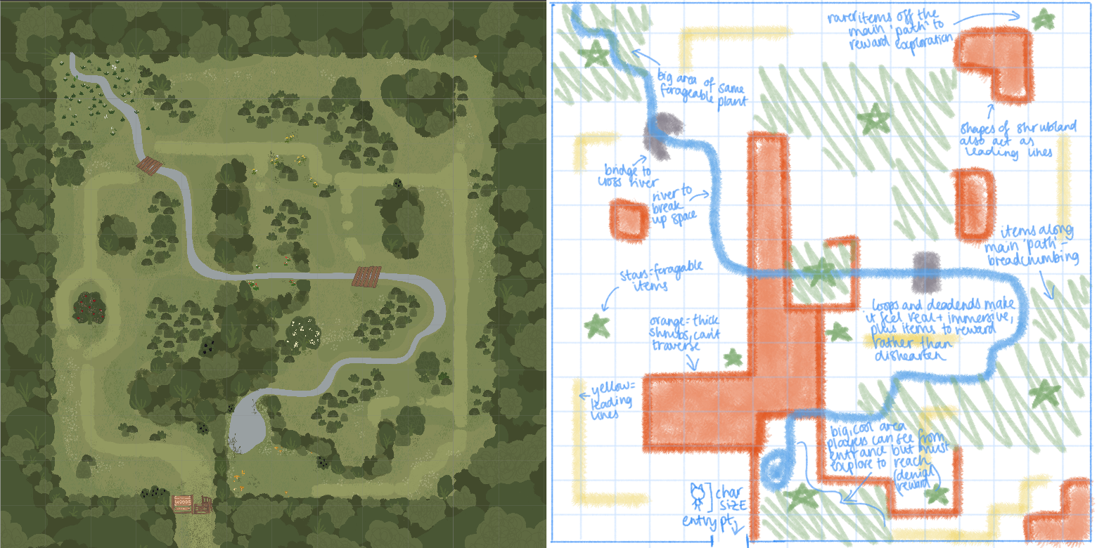

Figure : Side by side comparison of the final forest map (Left) to the original level design plan (Right)

The concept of denial and reward is applied at the entrance of the woodland to encourage exploration. As soon as they enter the woodland, players can see a large area filled with wild food and indicated as a good foraging spot. They immediately know that this is one of the spots they are trying to get to, but there is a row of shrubs between them and the area. To successfully reach the area, they need to navigate all around the edge of the woodland to finally reach the reward.

Leading lines are used to subtly encourage the player to explore in the right direction – rows of shrubs are placed in line with the ideal path, and player is effectively funnelled through the environment. There are enough spaces and open areas that it still feels like an open area free to explore, but the subtle direction ensures players aren’t wondering around aimlessly and instead feel like they are making progress.

In following the leading lines and trying to reach the large area visible from the entrance, players are automatically lead through other good spots on the map. This is a concept called ‘breadcrumbing’ and tells the player that they are heading in the correct direction. This also means that if for whatever reason the player gets bored of exploring the woodland, they don’t need to reach the big area at the end to satisfy the objective and move the story forward. If they do enjoy the process of exploring, they are rewarded not only with the large area at the end, but also with smaller, trickier to find spots which are away from the natural path, rewarding deeper exploration.

### 5.4 Technical implementation

#### Dialogue and branching narrative

The branching narrative system for the project is built around the Yarn Spinner writing tool and the accompanying plugin for Unity. All dialogue is written in .yarn files, a plain text format that utilizes special syntax to create files which can be read by the Yarn Spinner framework.

The Yarn Spinner Visual Studio Code extension makes it easier to write in the correct syntax, and provides other helpful features, such as the ability to preview dialogue within VSCode. This was used in the development process to check flow and rhythm of dialogue quickly throughout writing. The extension also makes it easy to export dialogue in a runnable html format, which was used in the dialogue user testing (see section blah).

A key advantage of using Yarn with Unity is the capability to create C# and yarn scripts which can communicate with one another and trigger events.

An example of this is the functionality have future dialogue informed by previous conversations with characters, which is controlled by the Interactable.cs and the YarnManager.cs scripts.

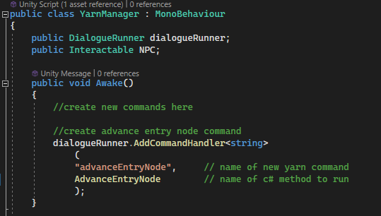

Figure : Code snippet demonstrating how command handlers are added to allow Yarn scripts to access C# methods

A new command handler is added to the dialogueRunner by the YarnManager with the yarn command advanceEntryNode, which references the C# function AdvanceEntryNode().

The AdvanceEntryNode() function takes in the name of the new node as a string, and passes it through to the current interactable so it knows what node should be opened when a player starts dialogue with them.

With the new yarn command advanceEntryNode, the node can be advanced from a specific line in the yarn script.

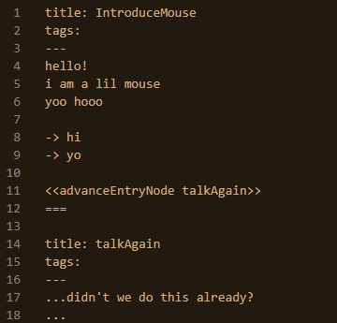

Figure : Code snippet demonstrating how yarn commands can be called from the plain text .yarn file

This means that as players interact with characters in the world and return to them, the characters dialogue and writing can change to progress the story forward rather than starting from the beginning every time.

However, despite success in implementing Yarn as the dialogue system for the product, there were issues throughout development. One of the problems encountered was the order of events when starting and finishing dialogue. Dialogue is progressed with the space button, and dialogue running is controlled in a locked script provided in the YarnSpinner package. However, the provided script set the Boolean value for when the dialogue was closed before executing the code which closes it. This meant that when the value was checked in my code to inform whether to start new a dialogue, the value would be misrepresentative of the actual state of the dialogue, leading to issues. For the small scope of this proof-of-concept product, a work around was implemented to separate the keys used to continue dialogue and start interactions, but this suggests that there could be unforeseen issues if the project were further developed using Yarn, because the built in scripts can have irregularities which cannot be altered by the developer.

#### Fog of war using Marching Squares

The Marching Squares algorithm is applied to create a system whereby the player explores an area to reveal corresponding areas of a mini map. Based on which vertices on a grid are on or off, a case is identified, and the corresponding square image is displayed in that tile. Using Marching Squares to achieve this fog of war effect on the map is an efficient way of checking the players world location and updating the map visuals accordingly without manually setting each individual pixel.

Figure : Diagram demonstrating the different cases of Marching Squares based on the values of the four vertices.

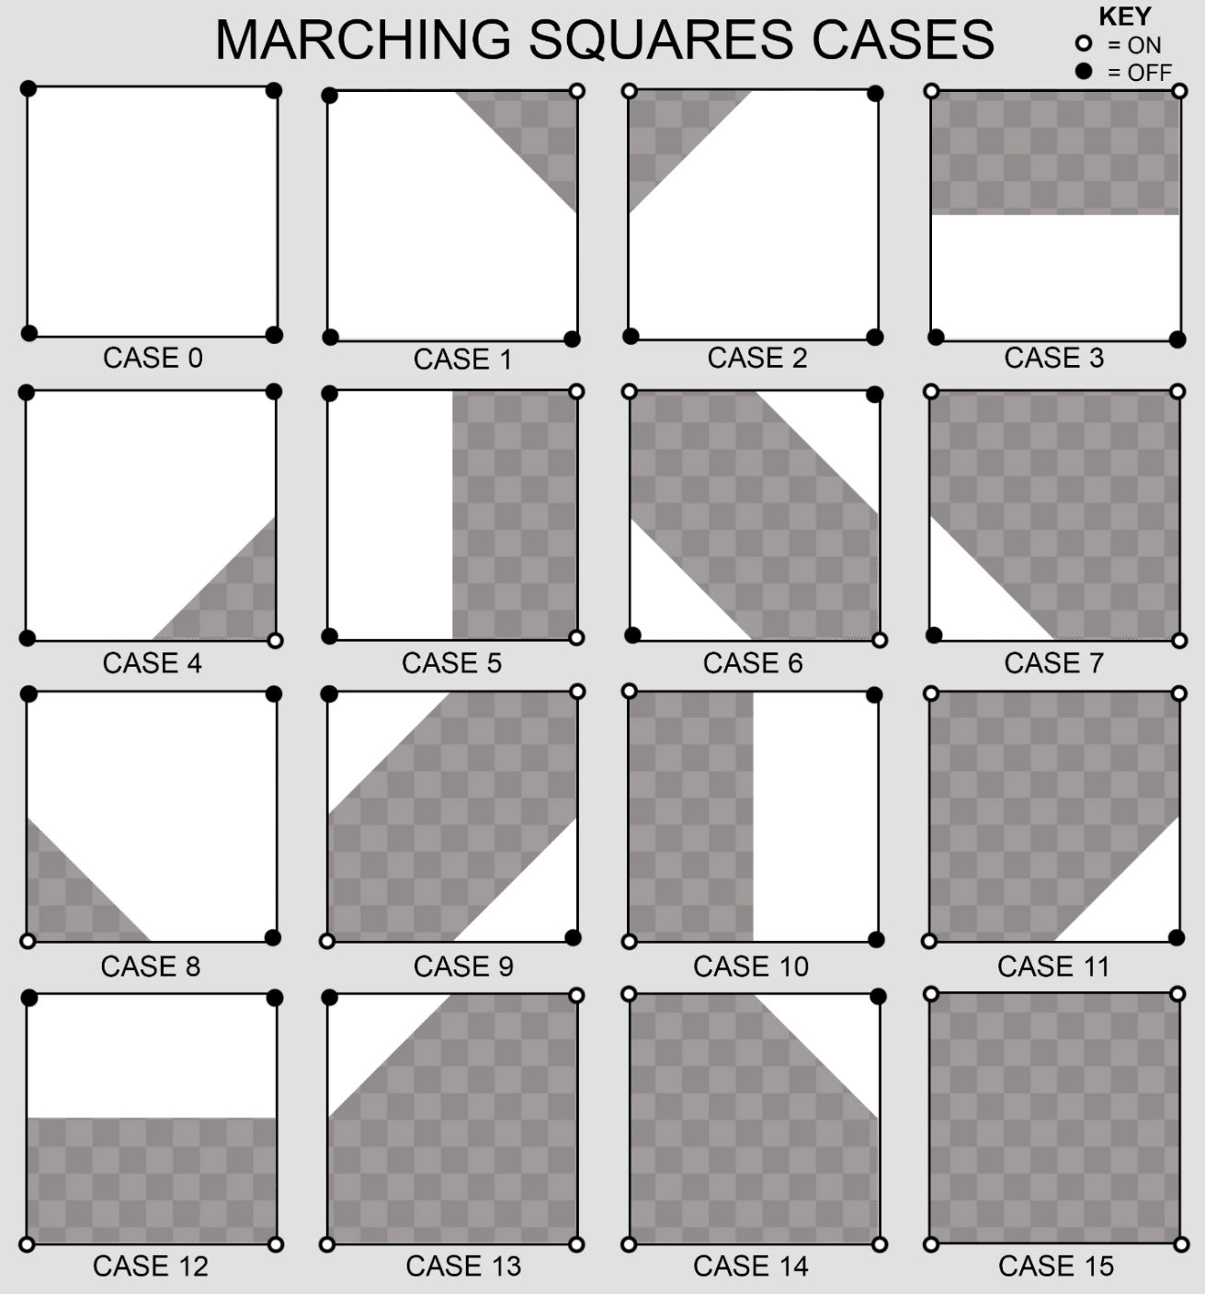

All the operations involved in the implementation of Marching Squares is controlled from the MarchingManager.cs class, which is attached to a GameObject in the relevant scene. The custom classes Square.cs and Vertex.cs represent the vertices and squares that make up the grid used for Marching Square calculations.

The Square.cs class contains a list of the four vertices associated with the Square, a conversion list used to convert vertices info into Marching Squares references, a reference to the Marching Manager in the scene, and a Vector3Int containing the Squares position.

It has two functions. OnVertexUpdated() is called by the vertex script and checks the state of each vertex attached to the square, converts the values into a reference number between 0 and 15 which refers to a Marching Squares image.

The updateTileSprite() function takes in the new Marching Squares reference number and updates the current tile accordingly.

The Vertex.cs class contains a list of the squares it’s associated with, a bool for current state named isOn, and a Vector3Int position.

It’s only function is IsOn() getter/setter. The get function returns the value of isOn. The set function is called by the MarchingManager.cs script when player movement triggers a new vertex to be turned on, and calls OnVertexUpdated on each of it’s associated Squares.

On Start, MarchingManager.cs uses a provided tilemap to create a 2D array of squares based on the bounds of the drawn map. This allows the developer to draw any tilemap before runtime and have it automatically acknowledged and converted to the array which can be accessed by other scripts.

Then the script creates corresponding 2D array of the vertices from the squares array, applying offsets to each of the square positions to find the four corners of each square.

On Update, MarchingManager.cs gets the player position in world space, uses the helper function translatePlayerPosToTilemap() to translate it to a Vector3Int position on the tilemap, and calls turnVertexOn() on the vertex at that position on the tilemap.

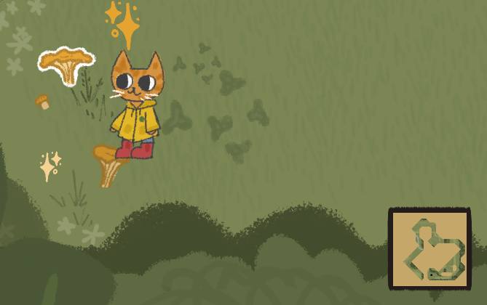In the product, this is used to create a fog of war effect over a mini map in the corner of the screen when exploring the forest. The Marching Squares sprites are varying proportions of opaque white and transparency. As the player explores, more of the tilemap becomes transparent, revealing the hand drawn map asset on the layer behind.

Figure : Screenshot showing the minimap as displayed in the forest area of the game, powered by the Marching Squares implementation.

### 5.5 Art and visual design

All the art assets used in the delivered product are original, made specifically for this project.

The art direction was explored in the Game Design Document (see Appendix 1 for the full document). Inspiration was taken from children’s illustration and cosy games, informing an original style that’s built around painterly textures, a warm colour palette, and soft, rounded shapes. This style was chosen to help make the game inviting and relaxing, encouraging play and providing escapism even when player may be feeling upset or unmotivated.

The game design document outlines designs for the player character and three non-player characters, though only one was implemented in the final vertical slice of gameplay. Each of the non-player characters in the world are inspired by British wildlife, making them separate from the main character, who is depicted as a ginger cat. This is one of the ways the visual design of the game reflects and reinforces the narrative design, showing the player character as a newcomer to the community.

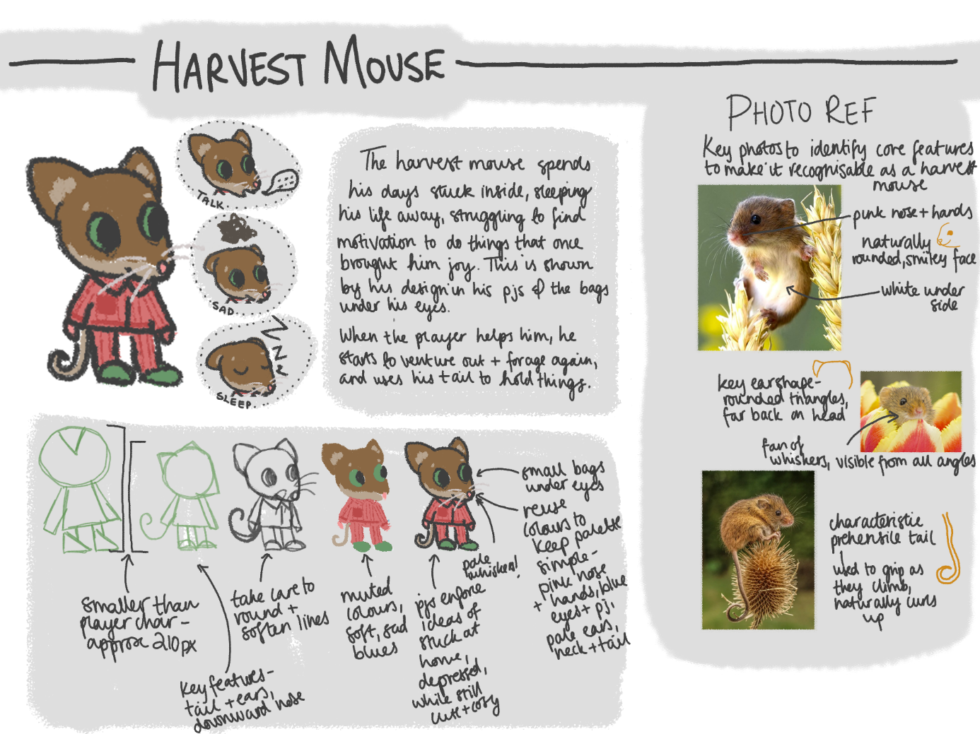To refine their designs, full concept art documents were created for each character, including analysis of the animal that inspires them to identify key features, breakdown of design process to showcase unique shapes and silhouettes, and demonstration of their facial expressions.

Figure : Concept art for the design of the Mouse character.

These concept documents helped ensure that all proposed characters mesh well together and simplified the process of creating the final game assets.

Similar documentation was created in the game design document identifying inspiration for the environment and user interface design. Identifying all these elements at the start of the project helped to define a distinct, cohesive style across the game.

The visual design of the village is inspired by rural English villages and hamlets. In a larger scale version of the game, there would be a full high street and village green to explore, but in the vertical slice there is just a small area where the player and Mouse interact. To ensure immersion and to make the limited space feel lived in and atmospheric, key visual elements of a quintessential English village are used to dress the scene. These elements are informed by research in the game design document, and include bunting, flower beds, and a country style garden in front of the Mouse’s house.

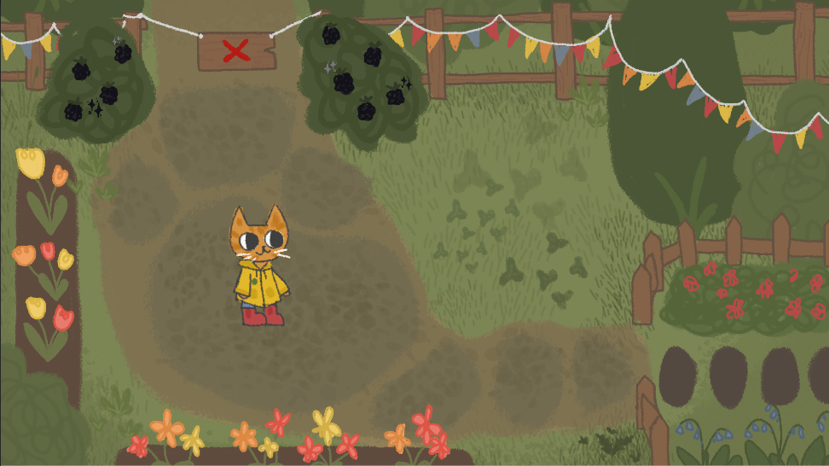

Figure : Screenshot showing the village scene of the game, as informed by the Game Design Document.

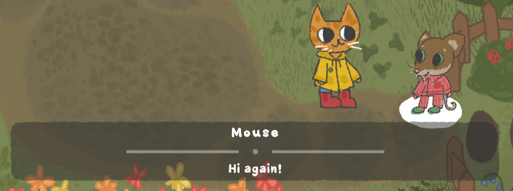Because the majority of gameplay and narrative is delivered through dialogue, the font is a key element of the visual design and experience of the game. The two main requirements of the font was that it is both easily readable, whether in the user interface or in longer form dialogue, and that it adds to the cosy, relaxed feel of the game. To deliver this, the project uses a custom font created for a previous module, Juicy Toon Font, which uses bouncy shapes with varying line weight to make the result both playful and legible.

Figure : Screenshot showing Juicy Toon Font being used for dialogue in the game.

### 5.6 Localisation

In the current vertical slice of the project, there is no scope for full localisation or translation to other languages, and the game is only available in English.

However, the content is designed in such a way that, if the project were to be developed further in the future, localisation could take place with minimal disruption to the existing framework.

This has been done by:

* Using no spoken words in the music or sound effects, so different language versions of the game can use the original sounds without rerecording them with translations.
* Using only the most basic elements of YarnSpinner to only control the flow of dialogue (no dynamic text replacement) so that it could be easily expanded with additional tags and a localisation database at a later point.

### 5.7 Accessibility

In the reduced scope of this project, there are limited resources to spend on accessibility, but efforts have been made to meet basic accessibility requirements.

The following basic requirements from Game Accessibility Guidelines have been met:

* Motor:
  + Ensure that all areas of the user interface can be accessed using the same input method as the gameplay.
  + Ensure controls are as simple as possible, or provide a simpler alternative.
* Cognitive:
  + Allow the game to be started without navigating through multiple levels of menus.
  + Allow players to progress through text prompts at their own pace.
* Vision:
  + Ensure no essential information is communicated through colour alone.
  + Use an easily readable default font size.
  + Provide high contrast between text/UI and background.
* Hearing:
  + Ensure no essential information is conveyed by sounds alone.
* Speech
  + No speech input is required.
* General:
  + Provide details of accessibility features in-game.
  + Provide details of accessibility features on packaging and/or website.

## 6 - Legal, social, ethical, and professional issues

### 6.1 Data Collection

User testing and surveys throughout the project involve collecting data from users. To ensure this doesn’t infringe on their right to privacy, each survey was prefaced by a written disclaimer explaining why the survey is being conducted, how results will be used, guaranteeing anonymity of respondents, and explaining how to contact the researcher for more information or to withdraw responses. To continue to the questions, users had to read the statement and tick a box confirming their understanding.

Some of the subject matter of the data collection included sensitive subjects such as demographic information and asking respondents about their mental health history. Every question was marked as optional to ensure that no respondents were forced to share information they’d rather keep private.

### 6.2 Mental health content

The project is based on using serious games to improve mental wellbeing. As part of this, the game both represents mental illness in characters, and suggests habits and techniques to improve mental health.

Poor representation of mental illness in characters could be a social issue, causing distress for users who suffer from similar issues. To ensure accurate representation, online accounts of depression and anxiety were used as reference. Care is taken to not go into detail of symptoms or actions which could trigger users, and instead the focus is on identifying commonly experienced feelings such as low-mood and nervousness.

In trying to improve mental wellbeing, it’s important to not dismiss people who struggle with their wellbeing, or to be put in a situation where players rely purely on the game as a source of information rather than seeking out psychological support. To prevent this, care is taken in the dialogue to present the habits and techniques as suggestions only which may soothe symptoms, rather than cures which claim to ‘cure’ mental illness. A disclaimer is displayed at the start of the game, accessible from the menu, and featured in the end credits. This explains that the product is intended to be a helpful resource rather than a replacement for professional help and encourages users who relate to problems represented to seek support from Mind UK or their GP.

### 6.3 Foraging content

In demonstrating the act of doing activities in nature, the game discusses and portrays characters foraging for food in the woodlands.

This could have serious consequences if users go on to forage themselves and either eat poisonous food or trespass and forage illegally on privately owned land.

To prevent users eating dangerous food, the characters discuss using a guidebook to help identify food that is safe to eat. This is translated into the mechanic which highlights edible food in the woodland scene, labelling the plants with their name. All plants referenced are safe to eat and legal to forage in the UK. Additionally, a disclaimer about eating food from the wild is displayed at the start of the game, from the menu, and in the end credits, explaining the importance of correct identification and providing resources to allow players to forage safely if so wish.

In the UK, the Countryside act (UK Government, 1968) allows people to forage for private consumption on common land. It stresses the importance of gaining landowners permission to gather on privately owned spaces, and encourages foragers to gather respectfully, leaving enough of resources for other people and wildlife.

The game content follows and references the Countryside Act. The woodland the characters explore and forage in is visibly labelled as ‘common land – foraging welcome’ to show demonstrate permission. When the player first learns about foraging from the non-player character, they discuss the legality of foraging and the Countryside act before continuing. Links to resources on foraging legally in the UK are provided with the disclaimers in the start, menu option, and end credits.

## 7 – Project Reflections

The project successfully created a vertical slice of gameplay which is enjoyable, polished, and researched enough to provide insight into how a larger scale execution of the objectives would perform. Art assets and written content have all been completed to a small scale but high quality, focusing on a smaller but more effective experience for users. User testing for the dialogue provided valuable feedback during the project to allowing refinement of the dialogue for a more effective and immersive final product. The game design follows the concepts from theories of learning and serious games to teach research supported approaches to managing mental wellness.

A key contributing factor to why these elements were well executed was the creation and following of a game design document and strict project plan at the start of the project. Spending time to plan out the project and create these reference documents allowed actual creation of the product to go smoothly with minimal disruption due to changes in product vision or time spent on features which aren’t relevant to the product. Part of the success of these planning documents was the time allowance to account for personal illness issues throughout the project. Chronic ill health issues are a common set back for the developer, so the project was planned with multiple buffer weeks to account for time off and with a prioritisation of tasks to ensure that even if time ran out, the key features needed to deliver the MVP were completed.

On the other hand, while adequate testing was conducted to inform the development of the product, there was no testing conducted to analyse how well the product teaches players about mental health issues or improves their wellbeing. This is one of the elements that was sacrificed as a result of the reduced scope project plan due to ill health. The health issues and delays are an external factor, but the content and structure of the content plan is responsible for which elements of the project were affected by the delays. Whilst on the whole, tasks were prioritised well in terms of delivering the product and the MVP, it would have been beneficial to prioritise the testing of the completed product. This would have allowed for better understanding of how well objectives were met and how the game affected audiences, rather than simply acknowledging that the game follows the findings of the preliminary research and literature review.

If I were to do this project again, I would prioritise user testing of the finished product to assess how well the game educates players on mental health habits and theory.

## 8 – Future development

Because the delivered product is a vertical slice of gameplay, there is a lot of room for future development to expand it into a full game which could be released.   
  
The Game Design Document provides a structure for this future development, providing an overview of the ideal product and all the elements that could be delivered.

One simple way to develop the product would be to add more content. Multiple characters in the village could represent different mental wellness struggles, and by helping all of them, players would be introduced to a variety of different healthy habits and techniques to manage their own mental health. This would also allow for more levels of complexity, as helping one character could unlock a feature required to help another. Two more characters are already identified in the game design document, including how their storylines could interact with one another and what they would teach the player.

Additionally, a greater area to explore in the town could allow for more visual storytelling to support the narrative – a noticeboard could direct players to characters needing help, and the aesthetics of the town could improve as more townspeople are helped.

## 9 - End-of-project report

At the end of the project, a narrative game that teaches about nature-inspired techniques to managing wellbeing has been delivered.

To access the completeness of this deliverable, the product is compared to the initial objectives outlined at the start of the project.

The first objective was *Write at least one character dialogue with a full storyline that they player can interact with.* This was met in the form of the Mouse character.

The player is introduced to the character, learns about their life, and through exploring and encouraging the character, they can help the Mouse to get outside and complete their storyline.

Secondly, objective two was *Write at least 5 minutes’ worth of dialogue for the player to read by the completion of the project. Measure this by entering the wordcount into wordstotime.com.* This is somewhat complicated to measure, as there are branching dialogue options with different lengths of writing for the reader to read. Overall, all the dialogue together totals approximately 35 minutes of content for the average reader. This doesn’t account for the branching dialogue options, so to get a better understanding of the average users experience, we can look at the time to read through the whole game if the player always picks the first options available to them. This gives a total of ___ words, which according to wordstotime.com would take the average reader --- minutes to read. This meets the objective of 5 minutes of dialogue, providing enough content for this vertical slice of gameplay to communicate the main narrative, style, and feel of a completed product.

Finally, the last objective specified *Make a slice of gameplay that can run from start to end without any major errors or bugs (eg, software doesn’t crash, players can move around and access the storyline as expected).* This aligns with the core elements delivered product; users can open the game, navigate through menus to get to the main gameplay scene, talk with the NPC to progress storyline, and interact with the world to satisfy requirements to complete the storyline. However, there are elements of the vertical slice of gameplay which were identified in the game design document which aren’t vital to the proof of concept, but which would complete the slice of gameplay. One of these elements is audio, which was identified and thoroughly planned in the Game Design Document, but which was deemed a low priority and as a result isn’t implanted in the delivered product. This means that although the product produced is a useful proof of concept for the product vision, it isn’t a complete vertical slice of the product as it would be if expanded and published.

Overall, the objectives identified at the start of the project have been met, surpassing the minimum viable product (MVP). However, as a result of task prioritisation within the product, some elements of the vertical slice of gameplay weren’t delivered, so that objective was only partially met. Regardless of this minor issue, the product itself is still strong, and demonstrates how a serious game can teach about mental health as well as being enjoyable, so, on the whole, the project was successful.

# References

Annerstedt, M. & Währborg, P., 2011. Nature-assisted therapy: Systematic review of controlled and observational studies. *Scandanavian Journal of Public Health,* 39(4), pp. 337-448.

Bandura, A., 1977. Self-efficacy: Toward a unifying theory of behavioral change.. *Psychological Review,* 84(2), pp. 191-215.

Beck, A. T., 1979. *Cognitive Therapy and the Emotional Disorders,* s.l.: Penguin.

Brau, B., 2020. Constructivism. In: *The Students' Guide to Learning Design and Research..* s.l.:EdTech Books.

Callender, M. et al., 2009. Transfer of Skills from Microsoft Flight Simulator X to an Aircraft. *International Symposium on Aviation Psychology*, pp. 244-249.

Chen, S. & Michael, D., 2005. *Serious Games: Games That Educate, Train, and Inform,* s.l.: Muska & Lipman/Premier-Trade.

de Jonghe, F. et al., 2001. Combining psychotherapy and antidepressants in the treatment of depression. *Journal of Affective Disorders,* 64(2-3), pp. 217-229.

Gatchel, R. J. & Rollings, K. H., 2012. *Cognitive Behavioral Therapy,* s.l.: Mosby.

ISFE, 2020. *Video Gaming in Lockdown,* s.l.: Ipsos.

Lau, H. M., Smit, J., Fleming, T. & Riper, H., 2017. *Serious Games for Mental Health: Are They Accessible, Feasible, and Effective? A Systematic Review and Meta-analysis,* s.l.: Frontiers.

McAdams, C., 2023. *Counseling Theories and Approaches.* [Online]   
Available at: https://counseling.education.wm.edu/blog/counseling-theories-and-approaches

Mind UK, 2021. *Ecotherapy.* [Online]   
Available at: https://www.mind.org.uk/information-support/drugs-and-treatments/talking-therapy-and-counselling/ecotherapy/

Mind UK, 2021. *Ideas to try in Nature.* [Online]   
Available at: https://www.mind.org.uk/information-support/tips-for-everyday-living/nature-and-mental-health/ideas-to-try-in-nature/

National Health Service, 2016. *Adult Psychiatric Morbidity Survey: Survey of Mental Health and Wellbeing, England, 2014,* s.l.: s.n.

Neumann, J., 2022. *Microsoft Flight Simulator Celebrates 10 Million Pilots.* s.l.:Xbox.

NHS , 2019. *Integrated health and care in action,* s.l.: NHS England.

NHS UK, 2020. *Counselling.* [Online]   
Available at: https://www.nhs.uk/mental-health/talking-therapies-medicine-treatments/talking-therapies-and-counselling/counselling/

Piaget, J., 1952. *The Origins of Intelligence in Children,* New York: International Universities Press.

Roszak, T., 1992. *The Voice of the Earth: Discovering the Ecological Ego,* s.l.: Trumpeter.

UK Government, 1968. *Countryside Act.* s.l.:s.n.

We need to talk coalition, 2013. *We still need to talk: A report on access to talking therapies,* s.l.: s.n.

White, M. A. I. G. J. e. a., 2019. Spending at least 120 minutes a week in nature is associated with good health and wellbeing. *Scientific Reports,* Volume 9.

Yusoff, A., Crowder, R., Gilbert, L. & Wills, G., 2009. *A Conceptual Framework for Serious Games.* Riga, Latvia , IEEE.

# Appendix 1 – Game Design Document

## Problem Domain

Many people would benefit from learning healthy habits and practices that improve their wellbeing, but people aren't given the opportunity to learn these skills until they reach a crisis point and need to seek help. It can be overwhelming and time consuming to start looking into psychology and mental health maintenance as an individual, which may dissuade people from making it a priority in their life.

Media can be a powerful tool to influence audiences priorities, interests, and opinions. Games as a medium can be a very successful educational tool, teaching people through play. Both games and media as a whole are likely to be more appealing to an individual than a self-help section of a bookshop. By researching how media affects audiences, I will make a game which aims to not only provide an enjoyable experience and escapism, but also to inspire better self care practices in users.

Exploring problem domain

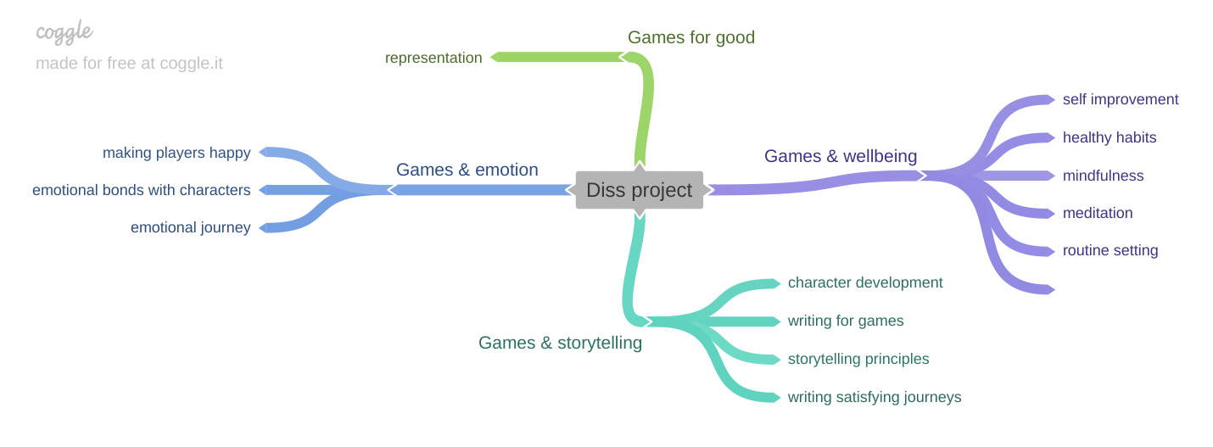

* Narrative game with a focus on wellbeing and learning self care practices.
* Inspired by the wholesome games movement.
* Informed by research about how media can affect audiences to change their own lives.
* Should have basic controls, more accessible to people who aren’t avid gamers.

## Study of similar products on the market

Considering similar games and applications for wellbeing, seeing what makes them successful, and what attributes from them I can take or leave when it comes to my own project. Asking the questions:

What is the product?

How does it aim to help users?

What makes it a good example of this type of product?

What parts of this will I keep?  
How will my game be distinct, offer something new?

#### Gris

|  |  |
| --- | --- |
| What is the product? | **Gris**, a game from indie developer [Nomada Studios](https://nomada.studio/), explores the emotional experience of traversing the trials and tribulations of grief through a beautifully designed, watercolour-style, puzzle platformer. |
| How does it aim to help users? | Gris a character going through grief that they can relate to, offering emotional support and understanding. |
| What makes it a good example of this type of product? | Gris communicates a complex, emotive story with symbolism rather than dialogue.  It’s been received well by audiences, selling over a million copies and winning multiple awards.  The approach to grief is informed by psychologists, especially the concept of the 5 stages of grief. |
| What parts of this will I keep? | I will also create story progression and goals inspired by psychology and informed by research.  I’ll look into how I can enhance my story with visuals, especially how game mechanics and colour are utilised. |
| How will my product be different? | My game will have multiple characters to interact with, so more of the storytelling will be done through dialogue.  Rather than capturing one specific experience, like Gris does with grief, my project will focus on general feelings of anxiety and depression. |

#### Night in the Woods

|  |  |
| --- | --- |
| What is the product? | **Night in the Woods** is an adventure game focused on exploration, story, and character, featuring dozens of characters to meet and lots to do across a lush, vibrant world. The themes addressed include mental illness, depression, the stagnancy of the middle and lower classes, and the slow death of small town America. |
| How does it aim to help users? | The main purpose of this game is entertainment - it shows a character struggling with some mental health issues, but it is not the main purpose of the game or the reason to play it. People choose to play it to have fun, and while they’re at it, may feel comforted and seen by the depictions of depression. |
| What makes it a good example of this type of product? | It depicts mental health accurately, as something that multiple characters deal with but which doesn’t define them. Minigames offer a break in the stress and dark world for both the main character and the player. The story and the main characters' experience is affected by who players choose to interact with more. There’s no right or wrong way to play. |
| What parts of this will I keep? | Character driven. Player choices influence the story without changing the overall direction of the game. |
| How will my product be different? | My product will be a slightly more hopeful take - rather than simply normalising and representing mental illness, I’ll focus on showing different coping mechanisms and representing characters grow and improve their wellbeing. |

#### Headspace

|  |  |
| --- | --- |
| What is the product? | **Headspace** provides [guided meditation](https://en.wikipedia.org/wiki/Guided_meditation) resources online, accessible to users through the company's website and via a mobile app on the iPhone and Android platforms. |
| How does it aim to help users? | Headspace teaches mindfulness to help cope improve mental health and wellbeing. |
| What makes it a good example of this type of product? | It’s proven to be effective - studies have found a significant increase in wellbeing, reductions in anxiety and depressive symptoms, significant reductions in diastolic blood pressures, significant increases in perceived job control, as well as a significant reduction in sleeping problems. |
| What parts of this will I keep? | Informed by science and psychology, easy to dip in and out of for short periods of time. |
| How will my product be different? | My product will provide entertainment as well as support, and aim to teach good habits which can be used outside of the product. |

#### CBT Companion

|  |  |
| --- | --- |
| What is the product? | **CBT Companion** is a companion app to learn and practise Cognitive Behavior Therapy (CBT) Techniques. |
| How does it aim to help users? | Teach users CBT and provide an environment for them to practise it in. |
| What makes it a good example of this type of product? | Focused on one specific approach to treating mental illness. Makes a proven form of therapy, CBT, more readily available and accessible to users so they don’t have to wait until they hit a crisis point to be referred to a therapist. |
| What parts of this will I keep? | I will include CBT methodologies as one of the techniques showcased in my game. I especially like the idea of teaching a specific approach, using the product as a way to teach and practise those skills, and then have users take away what they learnt into daily life outside of the product. |
| How will my product be different? | My game will provide multiple different approaches to mental health informed by therapy, and use gamification to help enforce lessons and make it more appealing to learn. It’ll appeal to a wider audience of people who casually want to improve their wellbeing without taking time out specifically to learn therapeutic techniques. |

#### Summary

|  |  |  |
| --- | --- | --- |
| Name | Image | Key takeaways for my project |
| Gris |  | * Visual storytelling * Informed by psychological theory * Hopeful |
| Night in the Woods |  | * Dialogue based storytelling * Entertainment first * Simple gameplay |
| Headspace |  | * Informed by psychological theory * Easy to pick up and put down |
| CBT Companion |  | * Informed by a specific treatment approach * Will include CBT methods as one of the options |

## Project Description

A small, character driven game set in a small village. Play is based around helping people in the town be happier. Each character requires a different type of task to help them out, each inspired by a different form of self-care or therapeutic practice. By helping others, the player character themselves benefits and builds themselves a better, more fulfilled, life.

Points to refer to:

* Calming escapism at the end of the day
* Informed by psychological practices
* Playable in short sessions

## Characters

### Player character

|  |  |
| --- | --- |
| Name | Turnip |
| Personality | Quiet, closed off, shy |
| Goals | Wants to settle into their new home and improve their life through connecting with the environment and the village inhabitants. |
| Appearance/  Inspiration |  |
| Notes | * Blank slate for players to connect with * Newcomer to the village |

### NPCs

|  |  |
| --- | --- |
| Name | Rabbit |
| Their problem | Anxiety, nervous, overthinking. |
| How to help them | Taking notice of nature – Take them somewhere they can see, hear, smell, touch nature. Collect these things into one place they can escape to and feel safe. |
| Reward | They have a calmer, slower demeanour  Start learning to tend to the world and make it full  Adding aromatic and pretty plants around the village  Free seeds sign added to noticeboard |
| Personality | Fidgetty, jump, shut away. Can’t complete tasks, keep spiralling and falling into traps of all-or-nothing thinking. |

|  |  |
| --- | --- |
| Name | Badger |
| Their problem | Isolation. Can’t leave house and need visitors. |
| How to help them | Bringing nature inside ; inspire with nature inspired hobby.  Bring them natural supplies to create based on the view outside their window. |
| Reward | Cheers up, opens up to new people. Fills house with art.  Posts art club on the noticeboard.  Paints new town sign. |
| Personality | Sad, irritable, snappy.  Stuck inside alone all day, reluctant to let people in (literally and figuratively) |

|  |  |
| --- | --- |
| Name | Harvest mouse |
| Their problem | Depression. Struggling to find joy in their daily life. |
| How to help them | Do activities outside.  Create a woodland trail for them to follow. |
| Reward | Helps things have more meaning.  Start finding joy in old hobbies again.  Starts foraging for goods that are available for free outside their house. |
| Personality | Quiet, spaced. To themselves. Stuck inside, monotonous. |
| Appearance/  Inspiration |  |

### Story

Start - disconnected little town, everyone keeps to themselves and isn’t happy

Middle - player starts helping people out

End - People are happier, player has a little party with people from town

## Setting

Small village/town in the British countryside.

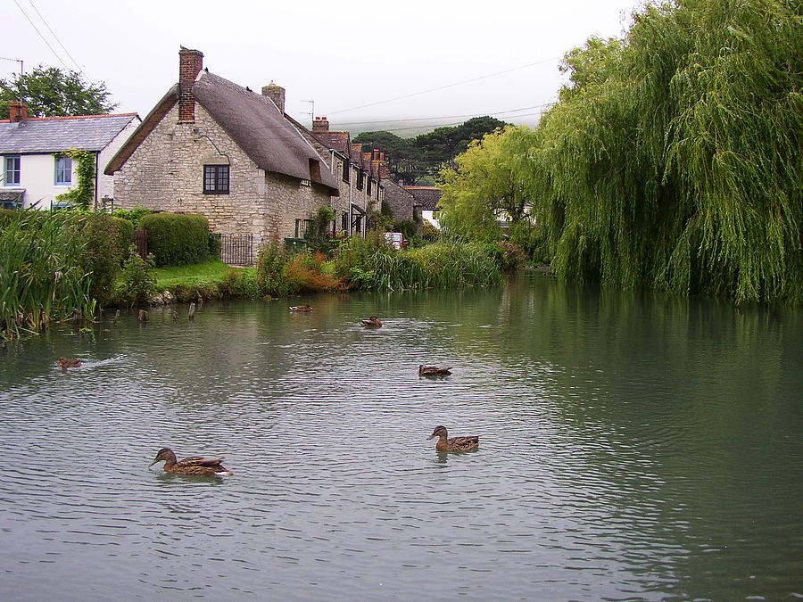

Real life inspiration - LLandidloes, Sutton Poyntz, Hurstpierpoint.

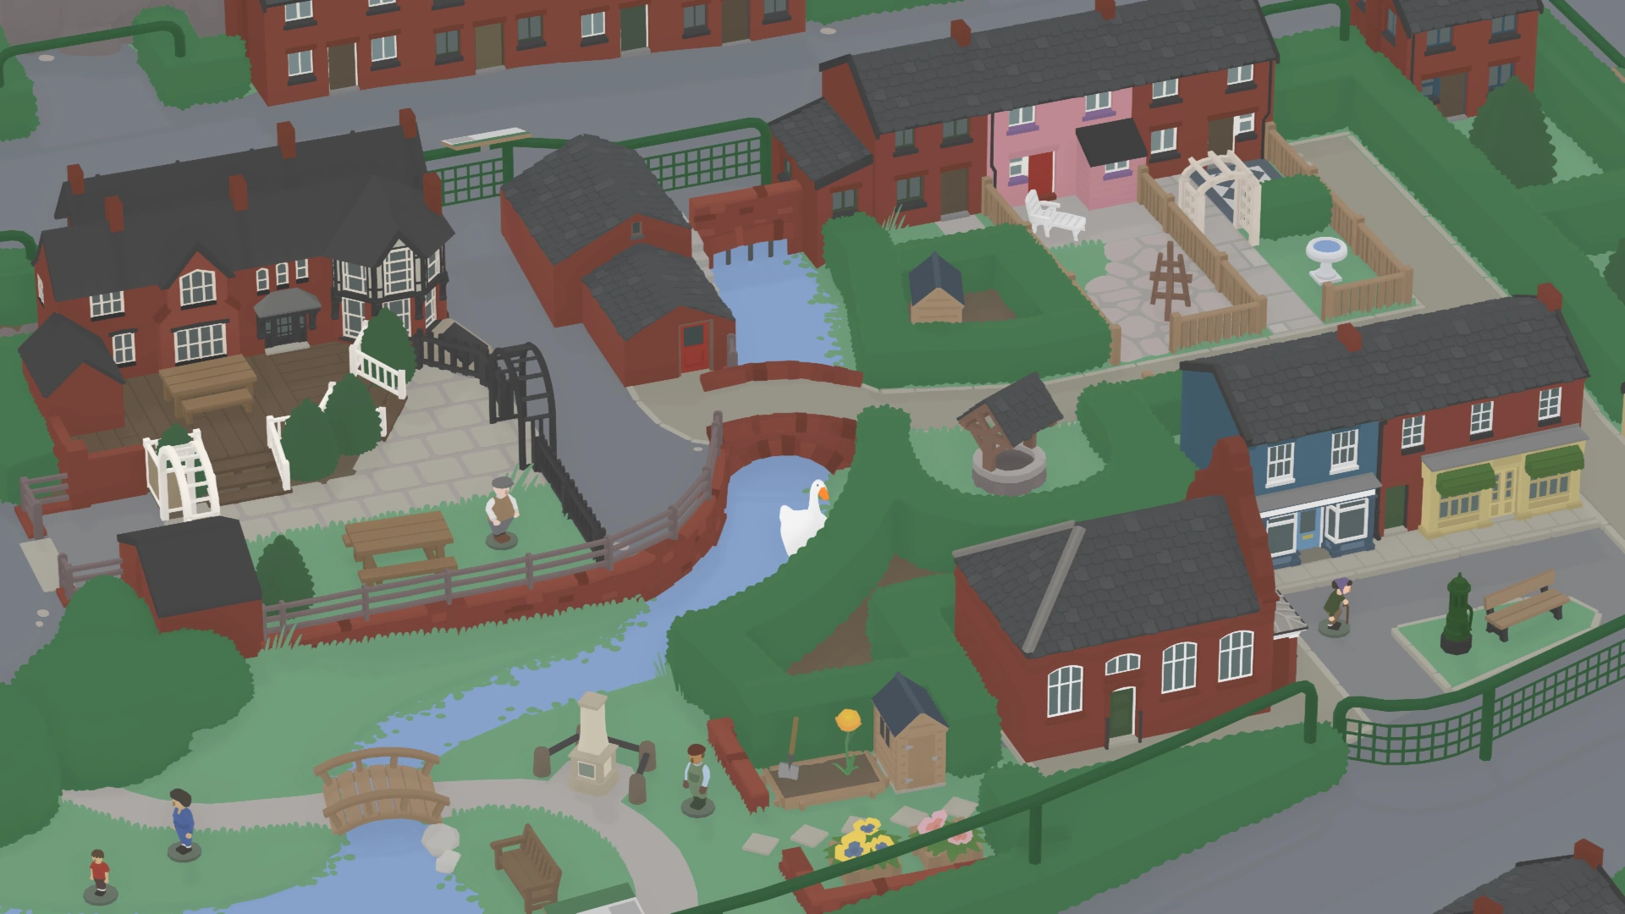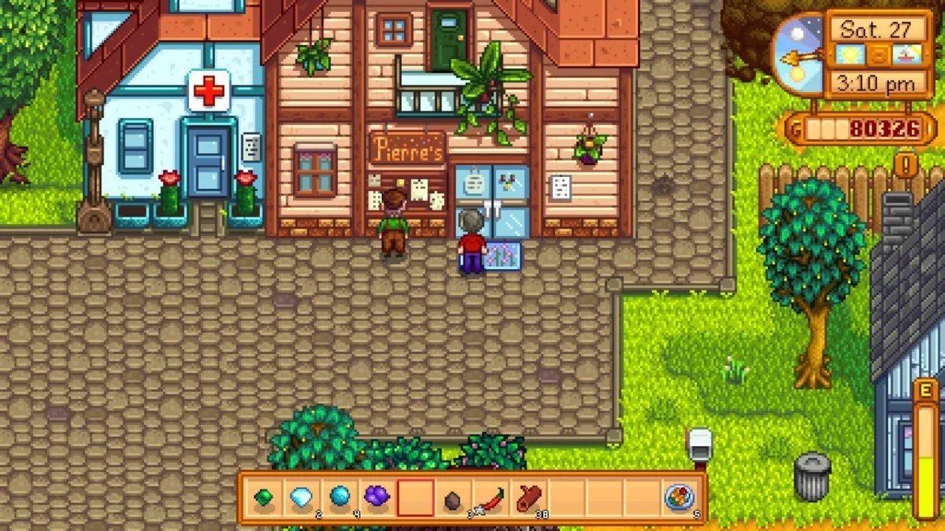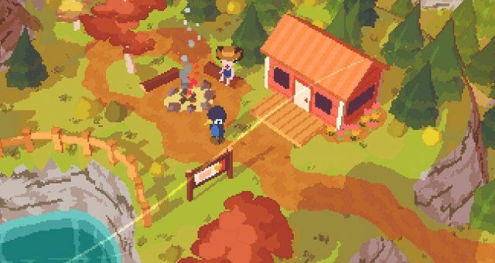

Game inspiration - Untitled Goose Game, Stardew Valley, A Short Hike.

Key points:

* Rural, countryside setting.
* Surrounded by nature - autumn.
* Selection of small independent shops required for the community to thrive.
* Central hub around duck pond with key shops, then houses and other businesses spread out into the surrounding country.

## Theme

The main theme of the story is this: different self care practices help different people. Helping others helps you help yourself.

## Story Progression

The player character has a diary which updates at certain milestones. Each entry is a mix of photos and writing which tell the story of the character’s emotional journey as they become more involved in the world.

The story progression of the world is told through subtle changes to the environment and characters, including:

* The town notice board
* The flowers in the village green
* The amount of people out and about in the town
* The behaviours and art of characters

## Game Opening

The game opens on the main character sat on the floor in their new house, surrounded by boxes. The character stands up, and the player can start controlling the movement. The only item that can be interacted with is the diary on top of one of the boxes.

Upon interacting with the diary, a pop up window shows a new journal entry, briefly explaining that the character has just moved and needs to explore. When the pop up is closed, the book is put back onto an empty bookcase in the background, and can be interacted with at any point.

After interacting with the diary, the player can go to the front door and leave out into the town and start exploring.

## The main game

As player explores the village, they meet a number of townspeople they can interact with. The town noticeboard helps nudge them in the right direction and suggest who they could try and find and help next.   
When a player successfully finishes helping a character, the surrounding town and the characters personality changes to reflect this.

Some examples of this could be:

* Helping a young person connect with nature and get outside and fresh air – they start appearing around town gardening and all of the flowers and plants in community areas perk up and flourish.
* Helping an older person reach out to old friends for a coffee and a chat – they are then found in the café, and start adding weekly meetup events like knitting club to the town noticeboard

## Ending

For the MAP version of the game, the game ends when the player has helped all of the characters in the village.

For the vertical slice of the game, the game ends when the player successfully helps one character.

In both endings, the final journal entry shows everyone together in the village green having a fair and being happy.

## Goals

### Short Term Goals

* Help others around the town to make them happy

### Long Term Goals

* Learn different ways people cope with life and make themselves happy
* Understand how people rub off on one another
* Build a closer community and have fun together

## Game Mechanics

Gameplay is intended to be explorational and story driven. The game mechanics are simple and should be easy for anyone to pick up and understand. Player actions are tools to help the user connect with and explore the world, and fun comes from this interaction rather than the actions themselves.

The player actions are identified as follows:

* Walk – 8 directional movement across an isometric plane. Controlled by WASD or arrow keys.
* Interact – When within range of a character or object that can be interacted with. Starts an interaction – could be dialogue or changing the state of an object. The interaction automatically ends when it is completed, and doesn’t require any additional input to return to normal gameplay.
* Open/Close diary – check journal for latest updates/character thoughts. Navigate through pages with arrow keys, and select the same button again to close the pop up and return to normal gameplay.

## Screens and user interface

Users navigate through the different screens according to this flow chart.

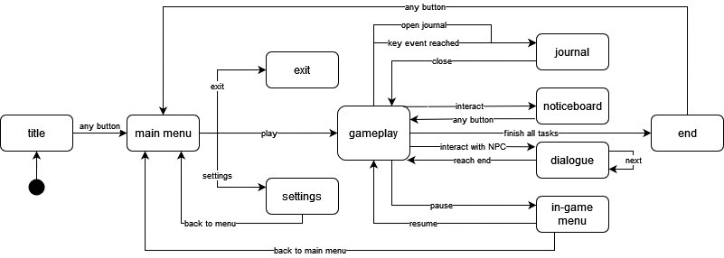

Overall, the screen navigation is simple and straightforward to make the game as accessible as possible.

The only unusual screen is the journal, because users can access it one of two ways – they can manually open the journal screen, but it will also automatically open when a key event that triggers a new journal entry is reached.

### Text Description automatically generatedTitle screen

* Game title front and centre in custom logo design
* Background shows the village and surrounding countryside
* Classic flashing ‘press any button’ pop up at the bottom

# 

### Text, whiteboard Description automatically generatedMain menu screen

* On start from the title screen, bg pans right so show this view with the signpost
* Each sign is a button, gets an interact outline when selected
* Can be clicked or scrolled through with arrow keys and selected with enter

### Settings

* 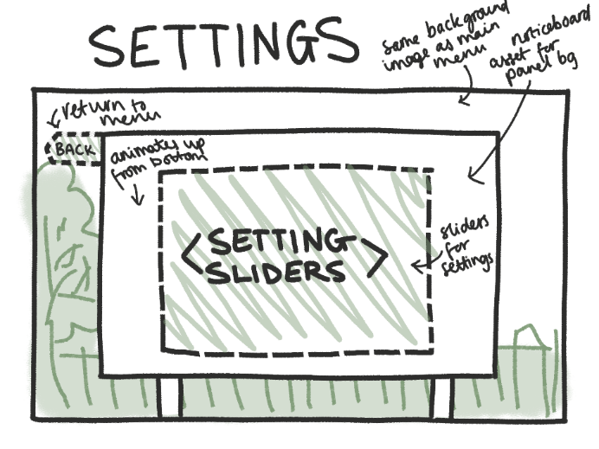Has a few key setting features here:
  + - * + Volume
        + Font size
      * Sliders for each setting
      * Uses the town noticeboard asset but reads ‘settings’ instead as a title
      * Back arrow returns to menu

### A picture containing text, cartoon, design Description automatically generatedGameplay screen

* UI during main gameplay is minimal, just an actions toolbar for settings and journal that can be clicked or selected with 1 or 2
* Player character is always on screen, offset from centre a la mario brothers so you can see what you’re exploring
* 2d assets with an isometric forced perspective
* Player character can move around and user actions from toolbar

### Text, whiteboard Description automatically generatedDialogue screen

* Dialogue pops up in normal gameplay mode
* Locks camera and movement
* NPC has a single speech bubble which comes up with chunks of dialogue which player can press a key to move on
* Player has a thought bubble with dialogue options they can scrollthrough with arrow keys and select with enter to pick
* Pop up toolbar is hidden in this view

### A sketch of a journal screen Description automatically generated with low confidenceJournal screen

* Can be accessed via journal button or when a key event happens and a new entry is added
* Automatically open to latest entry
* Scroll through entries with arrow keys or by selecting the arrow buttons
* Scrapbook style, with a main illustration of key event as well as any special items (eg tickets, seed packets) and a brief description from the player characters POV

### A picture containing text, sketch, handwriting, rectangle Description automatically generatedNoticeboard screen

* Accessed when player interacts with noticeboard in gameplay view
* Notices appear and disappear as jobs are done and activities are set up
* Important posts that indicate people the character can help are highlighted
* Either simple, few words, or icons
* Points player in direction of tasks
* Close by interacting again or selecting the cross

### A picture containing text, sketch, handwriting, drawing Description automatically generatedEnd screen

* Appears when all tasks have been completed
* Illustrated bg of villagers at a fair having fun, shows for a few seconds before credits start to roll over the top
* Includes thank you message, credits, and resources on getting mental health support
* Ends on ‘thanks for playing’
* Can exit with the close button at any time or with any button when credits finish

## Art Style

### Overall

This section describes the overall art direction of the game.

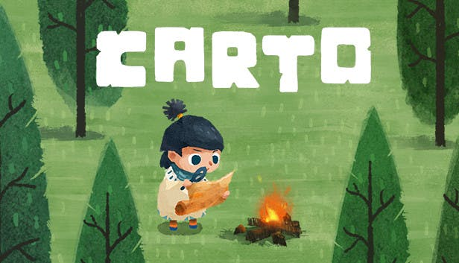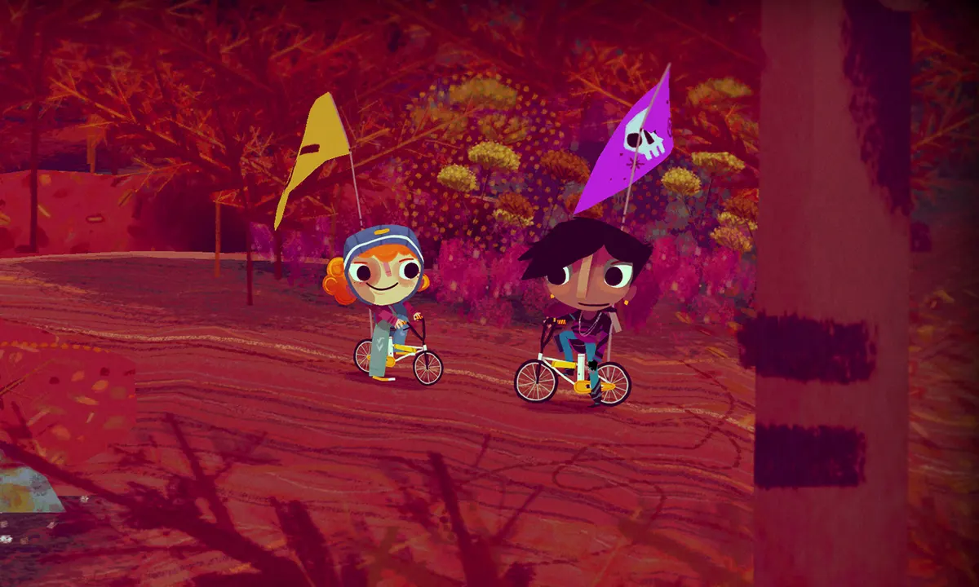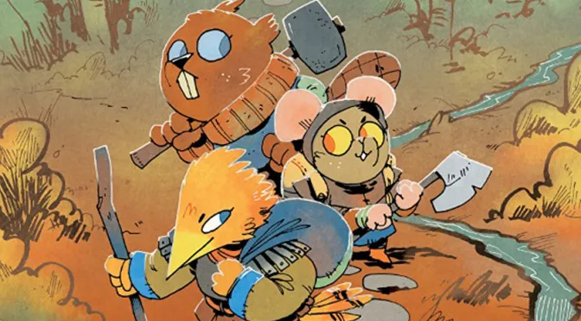

Examples, from left to right: Carto, Knights and Bikes, Root

* Two-dimensional
* Flat, simple shapes but with some painterly textures
* Organic, hand-drawn lines and forms
* Cosy colour palette

### Characters

This section describes the design of the characters in the game.

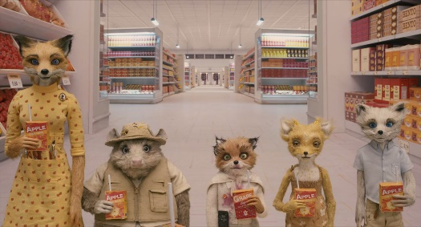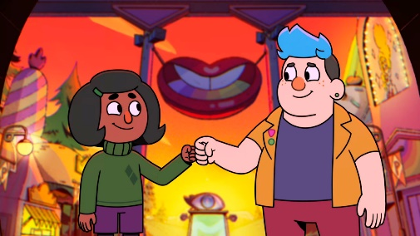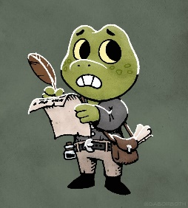

Examples, from left to right: Fantastic Mr Fox, Deadend Paranormal Park, Gábor Both

* Anthropomorphic animals with humanoid bodies and human clothing
* Soft, rounded body shapes
* Squishy, soft, organic forms
* Different line weight for external outlines
* Simple, plain clothing
* Simplified animal faces and characteristics – instantly recognisable, stylised rather than realistic

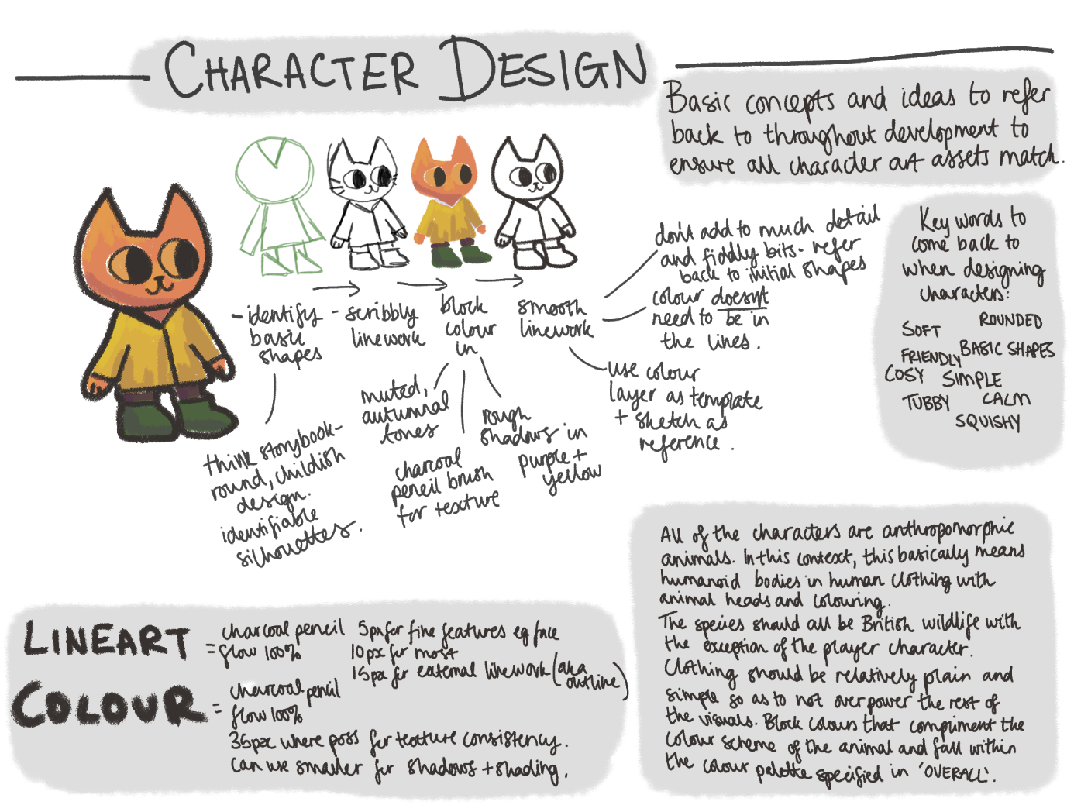

# Music and Sounds

Calm instrumentals throughout.

Keywords to describe the music: Acoustic, piano, relaxing, sleep music, calm.

Music is used to depict the mood of characters and narratives in the game but should never be too overwhelming as to take away the feeling of safety and escapism from the player.

The music is soft, gentle, and loops seamlessly to avoid ripping players out of their experience (see the piano instrumentals used in *Minecraft* for reference).

Soft, cartoony sound effects for interactions with other characters, the world, and the UI.

Keywords to describe the sound effects: Soft, whimsical, bouncy, cartoon.

Sound effects are used for each character to reinforce their thoughts and feelings without changing the overall atmosphere. Unique sound effects for each character also help define their characterisation and make them more memorable to the player.

These sound effects aren’t voice lines or dialogue, but rather onomatopoeia (such as hurumph, hmm, woohoo, haha) and nonsense language (see Animalise in the *Animal Crossing* franchise) which communicates personality and tone without being tied to a particular language.

These effects are recorded by a variety of actors and passed through audio editing software to remove background noise and adjust the tone and pitch to make them sound unique.

Sound effects are also used to help root the player in the world and add weight to their actions. Common actions such as walking, opening doors, and changing areas each have their own sound effect to accompany them. These effects are played quietly in the background to subtly enhance gameplay without drawing too much attention. Special items the player can interact with also have unique sound effects, which are played louder to emphasise their importance.

Similarly to the character effects, the environmental sound effects lean more towards stylised and cartoony than realistic and gritty (see the cooking montage sounds used in *The Legend of Zelda: Breath of the Wild* for reference).

These effects are a mix of synthesised audio from virtual instruments and foley recordings that have been heavily edited to make them sound more artificial and ‘bouncy’.

Sound effects in the UI are used to indicate which items can be interacted with, and to provide feedback when the user interacts with the UI.

The UI sounds are simple clicks and beeps, inspired by musical notes rather than harsh robotic noises (see the ‘healing in progress’ sound played in the *Pokémon* franchise for reference)

These effects are synthesized using virtual instruments.

# Technical Description

# Marketing

## Platforms and Monetisation

In the current vertical slice of the project, there is no scope to build for multiple platforms, controller sets, storefronts.

The game is built for Windows and is available for download from itch.io. The game is only available with keyboard-and-mouse and keyboard-only controls.

This game is available for free download with a suggested donation. This is to try and balance out making some income from the project without making it inaccessible to those who can’t afford to pay for it. This is especially important because it is a game which aims offer mental health support for those who cannot currently access professional support – to hide it behind a strict paywall makes it useless.

After the course of this module, there is an option to change the monetization and make it paid (£2-3) but with community copies available. The community copies will be consistently replenished to ensure it remains accessible to everyone.

## Localisation

In the current vertical slice of the project, there is no scope for full localisation or translation to other languages.

The game is only available in English.

However, the content is be designed in such a way that, if the project were to be developed outside of this module, localisation could take place with minimal disruption to the existing framework.

This has been done by:

* Using no spoken words in the music or sound effects, so different language versions of the game can use the original sounds without rerecording them with translations.
* Using only the most basic elements of Ink to only control the flow of dialogue (no dynamic text replacement) so that it could be easily expanded with additional tags and a localisation database at a later point. (Article on this process [here](https://johnnemann.medium.com/localizing-ink-with-unity-42a4cf3590f3))

## Accessibility

In the reduced scope of this project, there are limited resources to spend on accessibility, but efforts have been made to meet basic accessibility requirements.

The following basic requirements from Game Accessibility Guidelines have been met:

* Motor:
  + Ensure that all areas of the user interface can be accessed using the same input method as the gameplay.
  + Ensure controls are as simple as possible, or provide a simpler alternative.
* Cognitive:
  + Allow the game to be started without navigating through multiple levels of menus.
  + Allow players to progress through text prompts at their own pace.
* Vision:
  + Ensure no essential information is communicated through colour alone.
  + Use an easily readable default font size.
  + Provide high contrast between text/UI and background.
* Hearing:
  + Ensure no essential information is conveyed by sounds alone.
* Speech
  + No speech input is required.
* General:
  + Provide details of accessibility features in-game.
  + Provide details of accessibility features on packaging and/or website.

# Appendix 2 – Data Collection and User Testing

## Initial Data Gathering

Date: 02/11/2022

Aim: Collect project-relevant information about how people interact with media and mental wellbeing to inform the direction and next steps of the project.

Format: Anonymous digital survey, created with Google forms.

This research aims to help build up the background of the project and identify key concepts to be further investigated throughout the project. The questions aren’t related to the product I’ll be creating, but rather, to people’s attitudes and experiences with the subjects. There will be a mix of qualitative and quantitative data points, so that I can analyse trends and identify specific areas that respondents resonate with.

Artifacts:

The survey is saved as a PDF named *InitialSurvey* in **Documentation**>**Testing**.

## Dialogue Demo User Testing

Date: 01/03/2023

Aim: Gather user feedback about the storytelling, style, and writing of a small dialogue demo to inform the full dialogue and branching options for the main project.

Format: Anonymous digital survey, created with Google forms. Dialogue demo, created with YarnSpinner and available to play through in browser on my personal portfolio site.

This user testing aims see how effective my current approach to dialogue writing is at creating believable characters, communicating complex storylines, and encouraging expected responses from players. To ensure that all feedback is relevant to the writing itself, the dialogue demo provided is text only, with minimal user interface. The survey then asks a mixture of qualitative and quantitative questions, to provide an overall measure of the success of the demo, as well as detailed responses to gain insight into the smaller details and issues identified by users that I might not have accounted for.

Artifacts:

The survey is saved as a PDF named *DialogueDemoSurvey* in **Documentation**>**Testing**.

The demo is saved as a YARN file named *DialogueDemoYarn* in **Documentation**>**Testing**.

### Results and Analysis

Total participants: 6

Question by Question Analysis:

*Section 1: CHARACTERS*

*Q1: How would you describe the character you met? Consider attributes such as age, appearance, history, personality.*

* Old dusty grouchy lonely
* Elderly, someone who may have had a difficult past and has walls up as a result, somewhat defensive and cold but you can also tell that there is still a softer side to them despite them trying not to show any vulnerability
* Old and a little grumpy with some sort of interesting past
* Old, Single, Veteran, Introvert, Easily spooked,
* Retired pensioner living on her own, little to no visits from family or friends. Depressed, suspicious, lonely- they all present as irritability. Enjoys the company of birds & brushes but hasn't painted in a long time.
* They are old and lonely. Not much interaction with people. Soured by lack of people outwardly showing care for them. Came across more fem than masc. Loves nature, doesn't like people. Wants more than anything to share that love with someone, maybe had someone before that they lost.

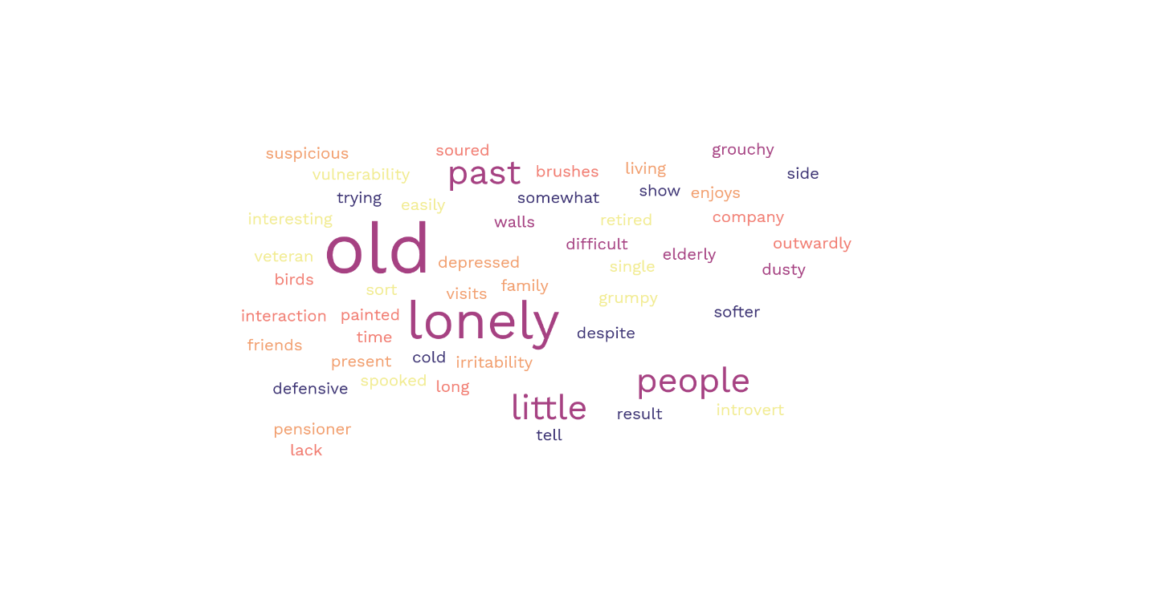

Figure 13: Word cloud generated from user responses to question 1

This question aimed to see if the character I had described in my Game Design Document could be effectively communicated to players from dialogue alone.

Even without any visuals, every participant identified that the character was old. Some other key characteristics defined in the GDD were also singled out, including their loneliness, keeping to themselves, and the concept that their irritability is mainly for show due to an awkwardness.

This is a really positive response and suggests that my writing style effectively communicates strong characterisation, rather than feeling flat, or vague.

*Q2: What problems would you guess the character might have in their life?*

* Loss
* Maybe relationship problems with family or others- not having good connections, and maybe not being accepted by people. Like having trouble making friends
* Loneliness, failed ambition, loss.
* Other people, they like their own company
* Primarily loneliness. If she does have any family they certainly don't visit often. On the rare occasion of human contact she reacts with hostility, likely because it's the path of least resistance for all the emotions she's had bottled up.
* Social anxitiy, lonelyness, issues with trust

This question aimed to see what the users would read into the character – no problems are explicitly stated, so it relies on successful subtle storytelling and building a character that users can empathise with and understand.

Every participant identified that the main problem the character faced was to do with other people – be it in the form of loss, loneliness, or social anxiety. This aligns with the character identified in the GDD, and supports the idea that users can read into their interactions to identify deeper issues.

*Q3: Which of these attributes would you say best describe the character? Select all that apply.*

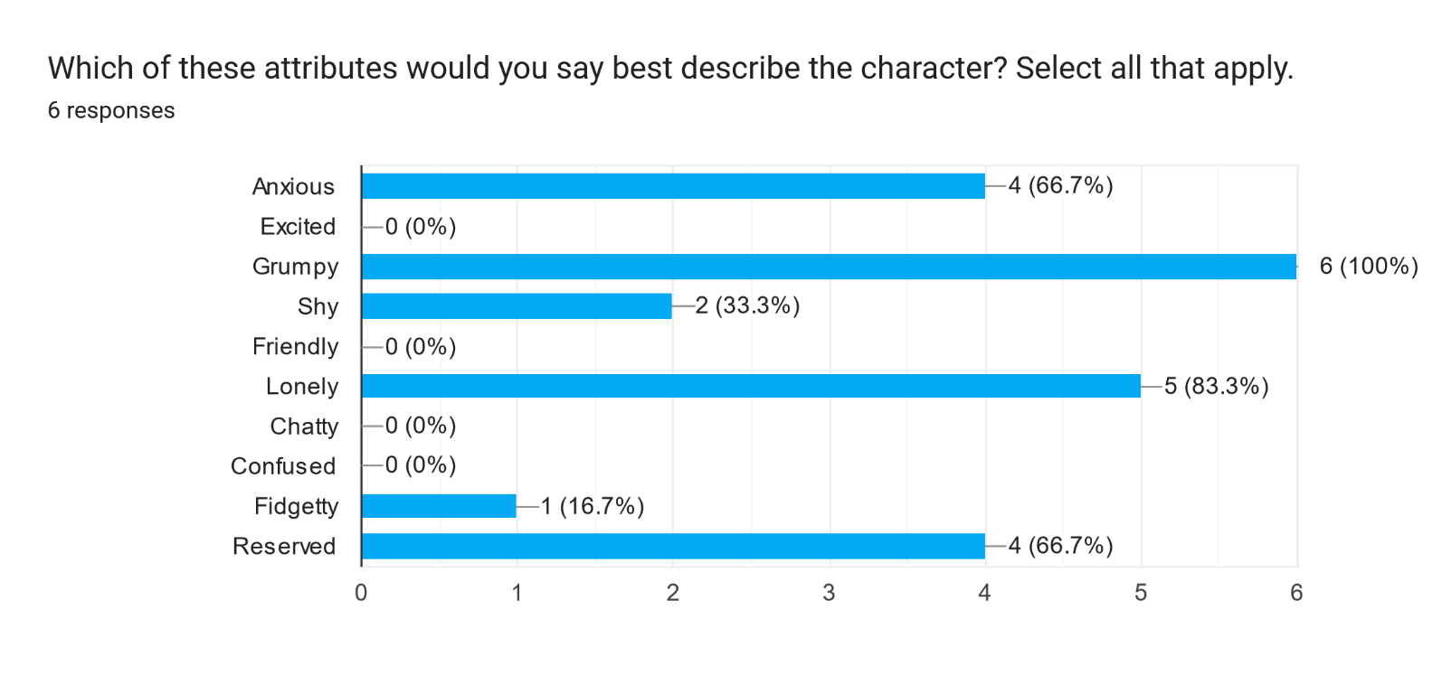

This question aimed to get some quantitative data regarding the characterisation of the character.

Participants generally aligned on the keywords they chose to describe the character, showing that the writing delivers a clear, cohesive concept of the character that is universally understood by users.

*Section 2: STORYTELLING AND ACTIONS*

*Q4: After interacting with the character, how likely are you to try and help them in the game? (1 being* ***definitely wouldn’t****, 5 being* ***definitely would****)*

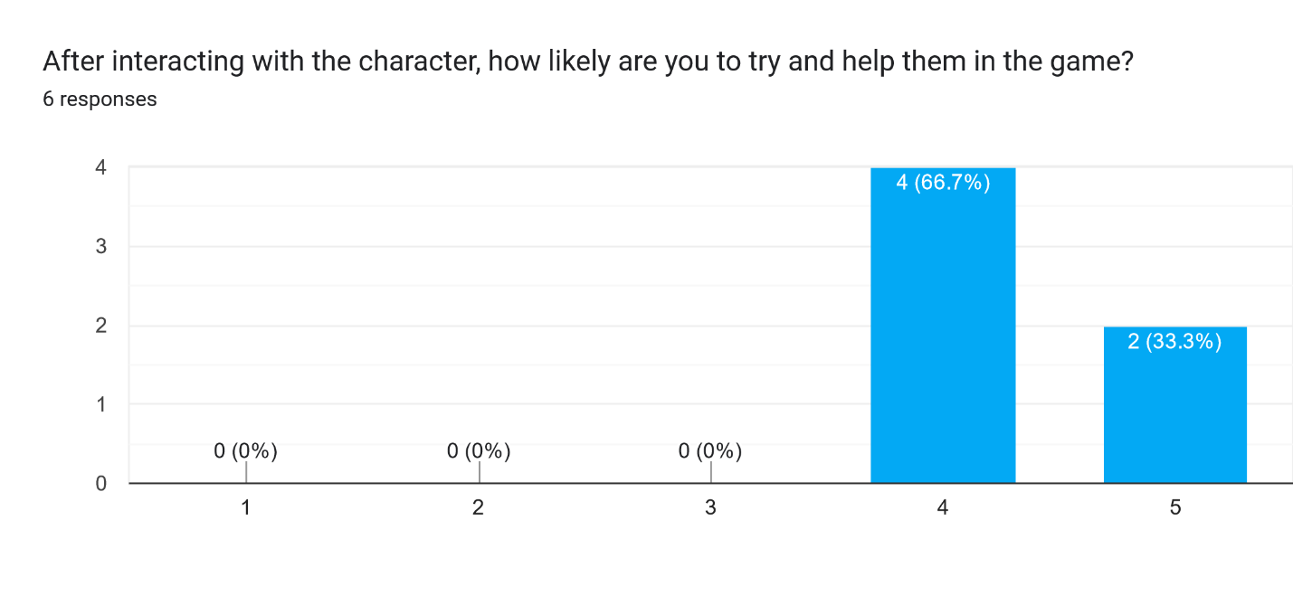

This question aimed to quantifiably check if players would, as intended, be inclined to help the character they met. Failure to strike the balance between a grumpy character that users still like enough to help would make the rest of gameplay feel forced and unnatural – if players don’t want to help the character but the only way to progress the game forward is to do so, they don’t feel as though they are the driving force of the game.

Thankfully, all respondents said they would try and help them in the game, showing that the storytelling successfully sets users up to follow flow of the story and be driven to complete the expected player actions.

*Q5: Do you think the player (you) could help the character? If so, how?*

* Get paint supplies
* I think the player could help them come out of their shell, by showing them care and respect as they did in the dialogue, and over time could help the person to trust people and feel less alone, especially as the characters are neighbours I think this gives them the time to slowly get there
* Try and engage further regarding the painting and see if it is a root cause for their anxiety.
* Give them painting supplies, install a bird bath outside their window, plant flowers for the insects to attract more birds
* Sneakily upgrade or refill their bird feeder. Anonymously deliver them new art supplies. Write to them instead of meeting in person, at least at first.
* Yes, by being a listening ear to hear about their love of nature and then past that creating areas in which you two can spend time with little talking. Doing different things alone.

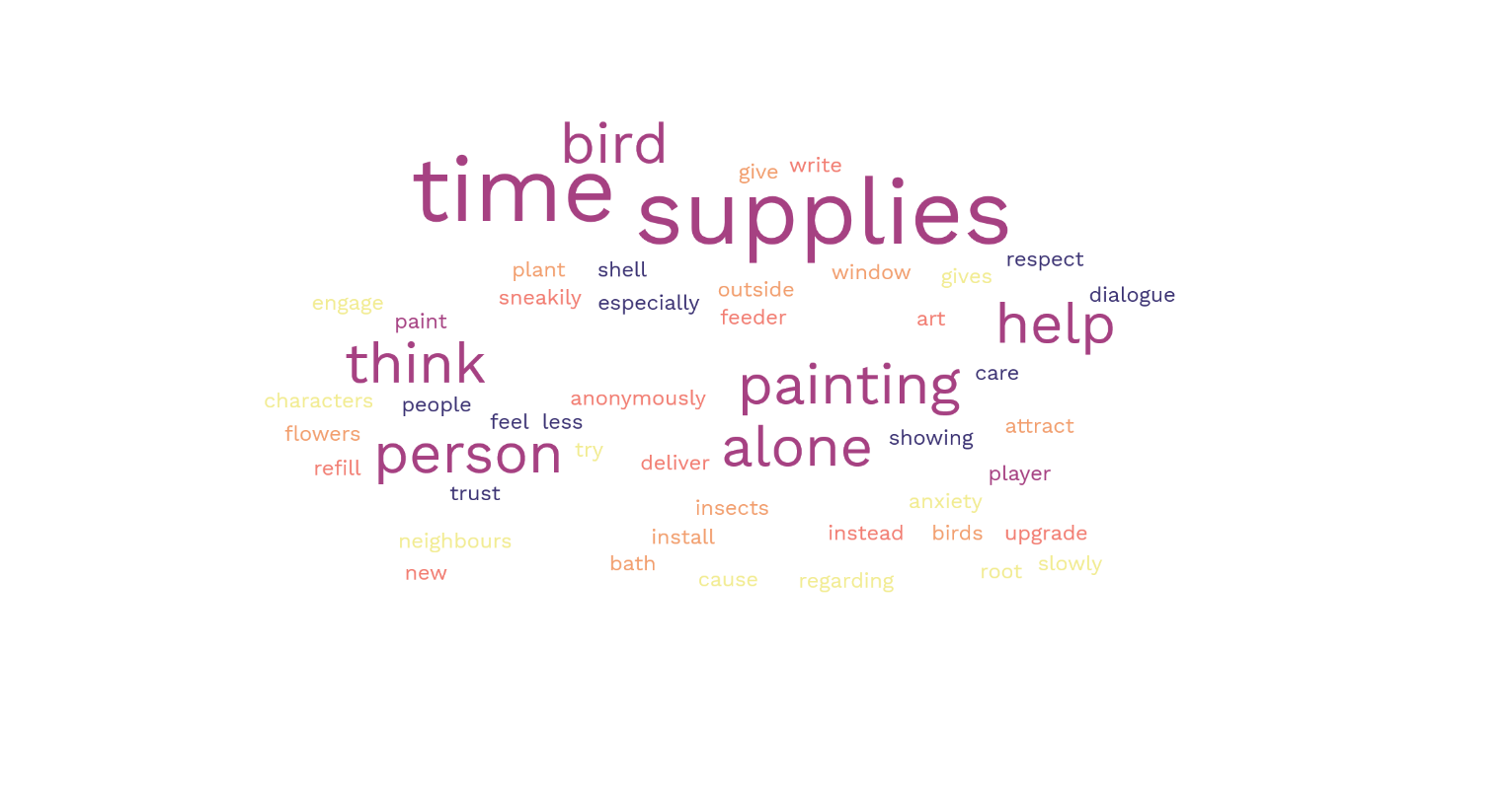

Figure 14: Word cloud generated from user responses to question 5

This question aimed to see what actions the players would be inclined to take in the game itself. Ideally, these would align with the solution identified in the GDD – bringing them art supplies, helping th

em build their interaction with nature and birds, and spending time with them.

As shown in the word cloud, the key themes of time, bird, supplies, and painting all came up a lot amongst responses. This is a positive result that supports the use of storytelling to subtly suggest solutions to problems.

In addition to describing the same type of help I had planned, respondents also identified some other ways the player could help which could be implemented in the game. Some of these ideas which I might reference in the dialogue and game design are:

* Installing a bird bath and planting flowers to attract more wildlife for them to enjoy
* Upgrading/refilling their bird feeder
* Helping them anonymously and writing to them to help ease their anxiety at face to face interactions
* Spending time together in a less-talky way – parallel play

*Q6: Do you think the character could help the player (you)? If so, how?*

* Teaching about birds and stuff
* Yes possibly as they could have things to share that they have never gotten to share with others before like practical skills but also I feel they would have potential to be a good and loyal friend if they became more comfortable and you built a relationship of some kind
* Not sure at this time - I'm more interested in their story
* Introduce them to their favourite spots in town, tell them about local events that new people might not get told about - like a guerilla gardening meetup or flower show
* I don't know enough about the player character to answer this.
* I think they are much wiser than I. They would know much more about the area especially in regard to nature and what the area needs from people

This question intended to look at how users would feel about an element I hadn’t explicitly planned. In designing these characters and their interactions, I only looked at how the player can help the character, so I wanted to see if the charactisation alone would drive users to come to similar conclusions.

As expected, some users didn’t know how to answer this question because they didn’t have enough information to guess.

The users who did have ideas all said the player could learn from the character – be it local information, events, nature knowledge, or practical skills. The fact that everyone aligned in identifying the character as an older, knowledgeable person who could teach the player character suggests that the characterisation is strong – everyone had the same understanding and thought process, rather than everyone pulling random ideas from thin air.

*Section 3: TONE AND STYLE*

*Q7: How would you describe the writing style? Consider the tone, anything it reminded you of.*

* Easy to read. Flows well
* Personal, detailed, immersive
* The writing certainly left me wanting to find out more - intriguing.
* Casual, short sentences, felt like natural dialogue
* Like an old GBA game.
* The writing style is jovial and lightherted on the surface but has a solum and awakrd undertone that bring the speed down to match the awkwardness

This question aimed to get a general understanding of how users felt about the style. The style is inspired by games such as *A Short Hike* and *Overboard!*, so any particular references to it being interesting, fun, light-hearted are especially positive.

All of the feedback was positive, and matches the general feel I was going for. I’ll continue to write the rest of the dialogue in a similar style, and create a quick reference sheet of key words and vibes to refer back to during writing so the style remains consistent throughout.

*Q8: Did you enjoy the writing style in this dialogue demo?*

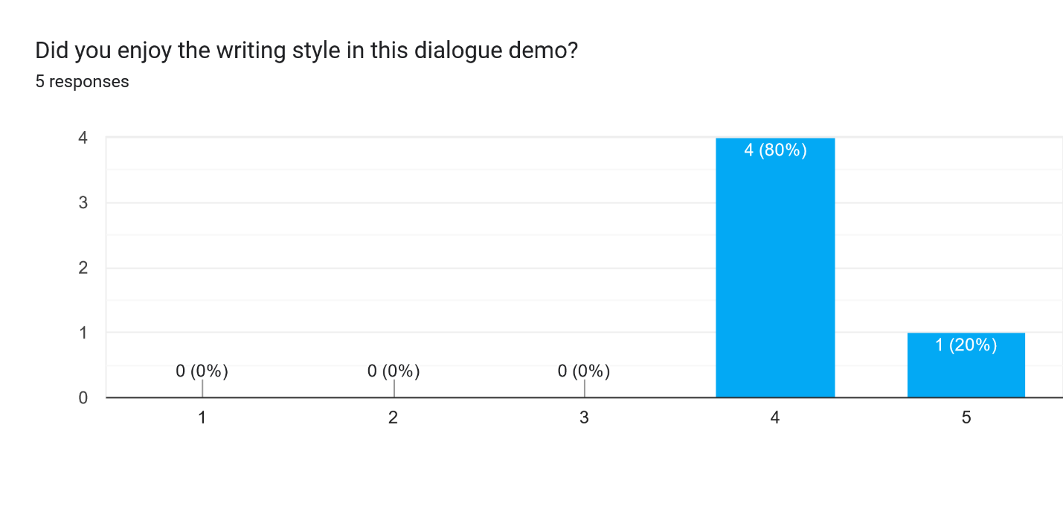

This question aimed to get a general idea of how much the users enjoyed the writing style – just because they described it as expected in my previous questions that doesn’t mean they necessarily enjoyed reading it.   
  
Overall the response to the style was positive – most people didn’t say it was perfect though, so I’ll be sure to take note of improvements I can make from the upcoming sections to make my writing the best it can be.

*Q9: What did you like and dislike about the writing?*

* I though that some of the options seemed out of touch from previous responses. It felt like through certain tracks the character was warming to me but then snapped in a slightly disingenuous way
* It was engaging and made me keen to go further
* Good pace. Nice options. I went back and did it again to get different outcome
* It was hard to tell who was speaking sometimes - this might be improved by visuals or colour coding though. For the most part it was okay but I couldn't tell who was screaming when I peaked through the window.
* I really liked how easy it became to imagine how it would feel to have the conversation with this person, with the descriptions of tiny nuances in the other person, as well as the way you portrayed the slight discomfort and uncertainty of not knowing how to respond to certain things they said

The aim of this question was to get some detailed feedback on the writing style, and hopefully some suggestions as to how to improve it because I felt like I lacked a bit of direction when creating the demo.

This section provided me with the most constructive criticism I can use to improve the writing.

Someone pointed out that the dialogue seemed out of touch with previous responses, and the characters mood would change unexpectedly. This is because I created branching narrative options, but didn’t have previous interactions affect tone of future ones – I’ll work on having the tone vary based on previous interaction to make it feel more natural and less disjointed.